

**Vinod Sahan Nawarathna**

2136690

**Conqueror Gamer Management by using an Artificial Intelligence (CGM)**

BSc (Hons) Computer Science and Software Engineering

Undergraduate Thesis Report

University of Bedfordshire

Dr. Yasas Jayaweera

### Academic Year 2022/2023

# Abstract

Conqueror Gamer Management (CGM) is a desktop application that offers PC gamers a number of services, such as in-game image capturing, the construction of player achievement pages, PC optimization for video games, and time management tools. The program's main objective is to put a strong emphasis on effective time management and offer pre-defined time packages in a simple style. With a variety of game-related assistance features, CGM is a special system that distinguishes it from other computer game programs. Conqueror Gamer Management (CGM) was created utilizing the IntelliJ IDEA IDE and the programming languages JavaFX and FXML. JDBC Driver was used to connect to the database after it had been created using MySQL Workbench. To enhance system performance, the development team used hybrid models as algorithms. The program's datasets came from Kaggle, a well-known online database. The team used a number of tools and approaches to provide an intuitive and user-friendly interface, which was another crucial component of the project. Overall, the programme was built effectively and in accordance with the specifications thanks to the application of these techniques and tools. The system is currently finished and offers PC gamers a number of advantages, including effective time management, optimized PC gaming, and user-friendly features. The study shows the significance of time management in the game industry and offers insightful information about the advantages of utilizing AI in the creation of computer game programs. CGM offers special features and advantages that improve the gaming experience, making it an invaluable addition to the PC gaming market.

# Acknowledgement

My profound gratitude goes out to my boss, Dr. Yasas Jayaweera, for his crucial advice, mentoring, and support throughout my project. His knowledge, helpful criticism, and unwavering dedication have all contributed to the success of our project. I sincerely appreciate his commitment, tolerance, and enlightening remarks, which have assisted me in overcoming obstacles and achieving my objectives. Next, I want to thank Lecturer Dr. Guyana Fernando for his wise counsel and lessons, which helped me stay on course and accomplish my objectives. I also want to thank the University of Bedfordshire's evaluators for helping me and supporting me while they evaluated my research from beginning to end. Finally, I would want to express my gratitude to the SLIIT Academy faculty, staff, and colleagues for their invaluable support and assistance in making my project a success. This project would not have been possible without their assistance, inspiration, and guidance, and I am eternally grateful for all of their support.

# Dedication

I dedicate my paper to my loving and devoted family, who have always believed in my ability to study the course material and have been incredibly supportive of me throughout my academic endeavors. In addition, I would want to thank my coworkers and everyone else who has helped and supported me as I have finished this project. You have given me the inspiration and direction I needed to be successful.

# Table of Contents

**Table of Contents**

Academic Year 2022/2023 1

Abstract i

Acknowledgement ii

Dedication iii

Table of Contents iv

Figures collection vi

Tables summary vii

Code-Snippets list viii

1. Introduction 1

1.1 Project Background 1

1.1.1 The problem definition 1

1.1.2 Project Realization 1

1.1.3 The Project’s Scope 2

1.1.4 Conclusion 2

1.2 Aim and Objectives 2

1.2.1 Aim 2

1.2.2 Objectives 3

1.3 Project Framework 3

1.4 Report Organization 4

1.1.1 Introduction 4

1.1.2 Literature Review 4

1.1.3 Market Research and Feasibility Study 5

1.1.4 Methodology 5

1.1.5 Designing and testing artefacts 6

1.1.6 Assessment 6

1.1.7 Final Verdict 6

2. Literature Review 7

2.1 Introduction 7

2.2 The Current discussion and research on computer gaming addiction 7

2.2.1 Articles 7

2.2.2 Reports 8

2.3 Major issues in gaming apps and services 9

2.4 Comparable Applications 10

2.4.1 NVIDIA Geforce Experience 10

2.4.2 Game - Loop 11

2.4.3 MSI – Center 11

2.5 Computer–related health problems 12

2.6 The importance of time management in life 14

2.6.1 What is time management 14

2.6.2 Advantages of effective time management 14

2.7 Technologies Used 15

2.7.1 Artificial intelligence (AI) 15

2.7.2 Machine Learning Data Analysis Techniques 16

2.7.3 Data Processing Techniques Overview 17

2.8 Research Gap 18

3. Market research and feasibility study 20

3.1 Market research 20

3.1.1 Results of the questionnaire summarized 20

3.2 Feasibility study 24

3.2.1 Financial feasibility 24

3.2.2 Technical feasibility 24

3.2.3 Resource and Time feasibility 25

3.2.4 Risk feasibility 26

4. Methodology 28

4.1 Software development methodology 28

4.2 Planning 29

4.3 Gathering and Analyzing Requirements 29

4.4 Design 30

4.4.1 UML Diagrams 30

4.5 Implementation and Testing 31

5. Design and Testing Artefacts 32

5.1 Design Artefacts 32

5.1.1 Management of User Accounts 32

5.1.2 Management of Home Page 34

5.1.3 Management of Gaming Mode 37

5.1.4 Management of Hardware Monitoring 39

5.1.5 Management of Capture 42

5.1.6 Management of FPS Counter 44

5.1.7 Management of User Achievement 46

5.1.8 Management of Time Management Package 48

# Figures collection

Figure - 2‑1: Most popular PC games of 2023 8

Figure - 2‑2: System requirements (On Steam) 9

Figure - 2‑3: Store and purchase history (On Steam) 9

Figure - 2‑4: Interface of NVIDIA GeForce Experience Desktop Application 10

Figure - 2‑5: Interface of Game-Loop Desktop Application 11

Figure - 2‑6: Interface of MSI - Center desktop application 12

Figure - 2‑7: Correct posture (Posture: Don't be a slouch! - spineuniverse) 13

Figure - 2‑8: Machine Learning overview 17

Figure - 3‑1: Questionnaire-Gender 20

Figure - 3‑2: Questionnaire-Age 21

Figure - 3‑3: Questionnaire-Information of gaming app 21

Figure - 3‑4: Questionnaire-Game addiction 22

Figure - 3‑5: Questionnaire-Feedback of game addiction 22

Figure - 3‑6: Questionnaire-Time management practice 23

Figure - 3‑7: Questionnaire-Comments about CGM application 23

Figure - 3‑8: Questionnaire-Characteristics 24

Figure - 4‑1: Iterative waterfall methodology (2023) 28

Figure - 4‑2: Iterative waterfall methodology testing (Software process) 31

Figure - 5‑1: User interface(Login) 33

Figure - 5‑2: User interface(Sign in) 34

Figure - 5‑3: User interface(Home page) 35

Figure - 5‑4: User interface(Home page) 35

Figure - 5‑5: User interface(Gaming mode) 37

Figure - 5‑6: User interface(Joption pane) 38

Figure - 5‑7: User interface(Hardware monitoring) 39

Figure - 5‑8: User interface(Screen capture) 42

Figure - 5‑9: User interface(Fps Counter) 44

Figure - 5‑10: User interface(Achievements) 46

Figure - 5‑11: User interface(Time management) 48

Figure - 5‑12: User interface(Generate) 49

Figure - 5‑13: User interface(Generated time package) 49

# Tables summary

Table - 2‑1: Comparison of the CGM with existing systems 19

# Code-Snippets list

Snippet - 5‑1: Database Connection 33

Snippet - 5‑2: Button set on action 36

Snippet - 5‑3: Button FXML code 36

Snippet - 5‑4: Gaming mode 38

Snippet - 5‑5: Gaming mode button FXML 38

Snippet - 5‑6: Get updated hardware details 40

Snippet - 5‑7: Get cpu usage 40

Snippet - 5‑8: Hardware monitor FXML 41

Snippet - 5‑9: Hardware monitoring fxml call on btnMonitor button 41

Snippet - 5‑10: Capture Button on action event 42

Snippet - 5‑11: Capture and save screen shot method 43

Snippet - 5‑12: F1 button 44

Snippet - 5‑13: FPS counter method 45

Snippet - 5‑14: btnFPS on action event 46

Snippet - 5‑15: Achievement class call on home page 47

Snippet - 5‑16: Achievement FXML on action button 47

Snippet - 5‑17: Database connection 50

Snippet - 5‑18: Remove method 50

# Introduction

This report's introduction chapter gives a general summary of the project, outlining its history, goals, and artefacts, as well as the report's structure. The setting and reason for the project are explained in the project background, while the project's goals are outlined in the aim and objectives. While the report format describes the structure and organization of the report, the artefact description gives a general overview of the project's outcome. These components work together to provide the project a clear and succinct introduction and to set the stage for the remainder of the report.

## Project Background

Video game themes extensively permeated society during the 20th century, and today, video game-related activities may be found in every aspect of school and daily life. Addiction to video games, however, is an increasing issue. The researcher used artificial intelligence to create a desktop programme that assists players in time management and the formation of wholesome habits in order to address this issue.

### The problem definition

There is no evidence to suggest that playing video games negatively affects people's life. However, it is done by going beyond video games. Some video games lack a definite objective or an endgame that would allow players to play continuously, which is one of the main causes of video game addiction. The majority of games are also created to be incredibly appealing and inspiring for the players. As a result, long-term computer use can lead to bad posture, melancholy, and anxiety, which can all coexist with video game addiction. Recognizing that gaming is not required, however, is crucial.

### Project Realization

Conqueror Gamer Management (CGM) is a desktop application that researchers have created to solve the issue of video gaming addiction. The software employs artificial intelligence to review the player's biographical data and generate a schedule that works for them. The athlete is also taught good posture and how to limit their usage of technology via CGM. CGM, in contrast to other desktop video game programs, offers time management features to aid gamers in creating good gaming habits.

### The Project’s Scope

CGM is a desktop application created to assist athletes in time management and the formation of wholesome habits. A number of services are provided by it, such as image filtering, screen activity recording, player performance monitoring, PC game optimization, and time management tools. CGM is a comprehensive solution for managing video game addiction and fostering healthy habits thanks to these characteristics, making it more than simply another game programme.

### Conclusion

Finally, video game addiction is a developing issue that has the potential to harm people's health and wellbeing. Gamers can learn time management skills and form wholesome habits while playing their favorite games using PC Game Manager. CGM is a novel and practical approach to the problem of video game addiction since it makes use of artificial intelligence. By addressing this issue, CGM has the ability to enhance athletes' lives and encourage healthy behaviors in the digital era.

## Aim and Objectives

### Aim

It is impossible to overestimate the value of time management, particularly in the context of video game addiction. Excessive computer game playing can have a number of negative effects, such as poor performance at school or work, social isolation, and physical health issues. By providing default time packages, CGM gives users a simple and practical approach to manage their time and stay away from the dangers of video game addiction. The default time packages that CGM provides are thoughtfully created to strike a balance between letting players enjoy their games and making sure they take regular pauses to rest their bodies and minds. Players are guided by the programme through the selection and implementation of a time package, receiving helpful tips and reminders along the way. These alerts are precisely placed to make sure that gamers take breaks at the right times, maximizing their productivity and lowering their risk of burnout or addiction. CGM is an all-inclusive solution for controlling video game addiction and fostering positive gaming practices. This programme assists players in better time management and helps them avoid the dangers of excessive gaming by providing useful time management tools and adjustable default time packages. CGM allows gamers to play their favorite games without jeopardizing their health, productivity, or social life.

### Objectives

* to create Conqueror Gamer Management (CGM), an AI-based desktop application that helps gamers manage their time wisely and establish wholesome habits.
* To offer default time packages that are simple to use and obtain, assisting players in striking a balance between having fun with their games and taking regular rests.
* To assist players in choosing and implementing a time package, offering pointers and suggestions along the way to make sure they take breaks when they should.
* to provide a complete treatment for video game addiction, including visual filtering, time management tools, screen activity tracking, player performance monitoring, and PC game optimization.
* enhancing players' well-being, productivity, and interpersonal relationships while promoting responsible gaming habits and lowering the hazards associated with excessive gaming.
* to add to the ongoing debate on the problem of video game addiction and how technology may encourage good behaviors in the digital age.

## Project Framework

Conqueror Gamer Management (CGM) is a desktop application powered by artificial intelligence that was created to assist gamers in time management and the formation of positive gaming routines. Image filtering, screen activity recording, player performance tracking, PC gaming optimization, and time management tools are just a few of the capabilities offered by CGM.

The default time packages of CGM, which balance gaming enjoyment with regular relaxation to rest the players' bodies and minds, are one of its important characteristics. The app assists users in choosing and completing a time package by providing recommendations and reminders along the route. As a result, players get the rest they need at the right times, increasing their productivity and lowering the risks of overplaying.

A personal profile analyzer in CGM also creates a schedule that is suitable for the player after reviewing their biographical information. Players can document their progress and share it with others using the screen capture and screen recording features of the app. Players may check their progress and modify their schedules by tracking how many hours they spend on activities that are part of the time package thanks to the notification indicator, which sends email updates about this information to players.

Additionally, CGM has a Player Achievements tab that displays players' advancement and accomplishments. The website promotes responsible gaming practices and a welcoming gaming atmosphere. The app's features are purposefully created to assist users in time management, as well as to enhance their overall health, level of productivity, and interpersonal interactions.

Conqueror Gamer Management (CGM) desktop software is an all-inclusive method of controlling video game addiction and encouraging positive gaming practices. It provides a variety of features that aid users in time management and habit formation, ultimately enhancing their lives and promoting beneficial actions in the digital age.

## Report Organization

Introduction, Literature Review, Market Research, Methodology, Assessment, and Final Verdict are the six key chapters of this document.

### Introduction

The project background, aim and objectives, project framework, and report organization are only a few of the important elements that make up the report's introduction chapter. An overview of the project's scope and objectives is provided in the section on the project background. The project framework part covers the methods and approach utilized to attain these aims, whereas the aim and objectives section outlines the desired outcomes and goals of the project. The report organization section concludes by providing a summary of the report's organizational structure and the major subjects covered in each section. These parts work together to create a thorough introduction to the report, laying the groundwork for the reader to comprehend the project's context, goals, and overall approach.

### Literature Review

The literature chapter gives a thorough account of the author's study that was done to better understand computer game addiction and associated problems. The chapter is divided into several subsections, including an introduction that gives the subject's context and historical history. The chapter also discusses contemporary debates and studies on computer gaming addiction, as well as its causes and possible repercussions. The main difficulties and problems with game services and applications are also examined. Comparative applications are examined together with their benefits, drawbacks, and any obstacles for the proposed project. The physical and psychological hazards and issues that could arise from prolonged computer use are thoroughly covered. It is also investigated how productivity and time management are affected by games and computer use, as well as the significance of time management in daily life. Various technologies, coding languages, development tools, and hardware components utilized in video games and computer applications are also covered in this chapter. In the end, any gaps or restrictions in earlier research that are relevant to the project proposal are examined, and potential for additional study as a result of the project are noted.

### Market Research and Feasibility Study

The market research and Feasibility Study chapter discusses the techniques employed by the researcher, including surveys and result analysis. The objective was to acquire pertinent data that might be utilized to determine market trends, competition, and prospective demand for the project.

On the other side, the project's viability is examined in the feasibility study portion. This encompasses factors like money, technology, resources, time, and risk. Determine whether the idea is feasible, doable, and financially viable is the main goal. Insights from this study can be utilized to make conclusions about the project's prospects for success and sustainability.

### Methodology

The report's methodology chapter provides an in-depth description of the steps used for planning, data gathering and analysis, system design, implementation, and testing, as well as the methodology used to develop the system. The report covers the methodology utilized to develop the system and provides an explanation of the project's planning procedure. The chapter also gives specifics on the system's design and outlines the methods used to collect and analyze data. Finally, every facet of the testing and implementation of the application is covered in the report.

### Designing and testing artefacts

The report will include the design and testing artefacts in Chapter five, which will comprise images of the user interface (UI) components and the application's implementation with backend code segments. In addition, the chapter will include the findings of the tests performed during the artifact's testing phase.

### Assessment

The assessment process is covered in detail in Chapter 5 of the report, which also contains an analysis of the application review. Based on a thorough review process, the chapter offers a critical assessment of the performance of the application. The report describes the many methods and procedures used to assess the usability, functionality, and efficiency of the programme. The chapter also offers critiques of the application's advantages and disadvantages as well as recommendations for future enhancements. The evaluation process seeks to offer a thorough and impartial review of the application's overall quality and efficacy.

### Final Verdict

The report will include a thorough review of the project and its results in Chapter Seven. Limitations and future work that describe how the project can advance in the future are included in the chapter. The part will utilize formal language to offer a final evaluation of the project, outlining its advantages and disadvantages as well as making suggestions for further improvement.

# Literature Review

This review of the literature offers an overview of various attractiveness applications, technologies, methodologies, proper technological equipment use, benefits and drawbacks of apps connected to computer games, the significance of computer game addiction, and time management. It also evaluates how technically feasible the diversion is.

## Introduction

Understanding the many technologies used in computer game-related applications, comparable applications, usage of proper technical equipment, computer game addiction, and time management strategies are the main goals of this literature review. Additionally, this assessment offers important details concerning the technological viability of the suggested solution. To help the reader better grasp the topic, this literature review includes references to numerous research papers and publications. It comprises brief summaries of the key systems, a conclusion, and concise explanations of the data, figures, and diagrams. The review's style is professional and neutral throughout, providing facts in an unbiased manner.

## The Current discussion and research on computer gaming addiction

### Articles

The phenomenon of internet gaming addiction and its effects on people are the subject of Kuss and Griffiths' (2011) systematic review. The review emphasizes that internet gaming addiction is linked to symptoms including mood swings, tolerance, and cravings that are also found in substance-related addictions. Based on empirical data, the authors suggest a classification scheme for the state of scientific knowledge regarding internet gaming addiction. According to the paradigm, there are risk factors and etiological antecedents that precede internet gaming addiction along a continuum. Several systematic reviews have recently focused on the problem of internet gaming addiction. In contrast to Lam (2014), who undertakes a comprehensive study of the relationship between internet gaming addiction, problematic internet use, and sleep issues, Guermazi (2017) examines video and internet gaming addiction among young individuals. In order to study the parental and family factors connected to problematic gaming and problematic internet use in teenagers, Nielsen et al. (2020) conducted a systematic literature review. These assessments shed further light on the intricate nature of internet gaming addiction and its possible effects on people's lives individually and as a unit in families.

### Reports

Hopkins (2022) published a paper on gambling addiction, which is a major public health issue in the UK due to the popularity of video games. Three to four percent of gamers globally have video game addiction, affecting at least 60 million people, according to a 2021 comprehensive study that was included in the report. Video game addiction has also been acknowledged by the World Health Organization (WHO) as a mental health issue. When a person can't resist the impulse to play video games, puts gaming ahead of other commitments, and keeps playing despite negative effects, a diagnosis is made. The report's experts conducted in-depth study on gambling addiction in the UK among various age groups and found the games and subgenres that were the most addictive. The paper emphasizes how crucial it is to be aware of the signs and potential therapies of gaming addiction, particularly as younger audiences have easier access to gaming. According to the survey, many games are projected to become addictive by 2023, with the top 30 most addictive titles including Minecraft, Fortnite, ROBLOX, and The Sims 4(Most popular PC games - global 2023).

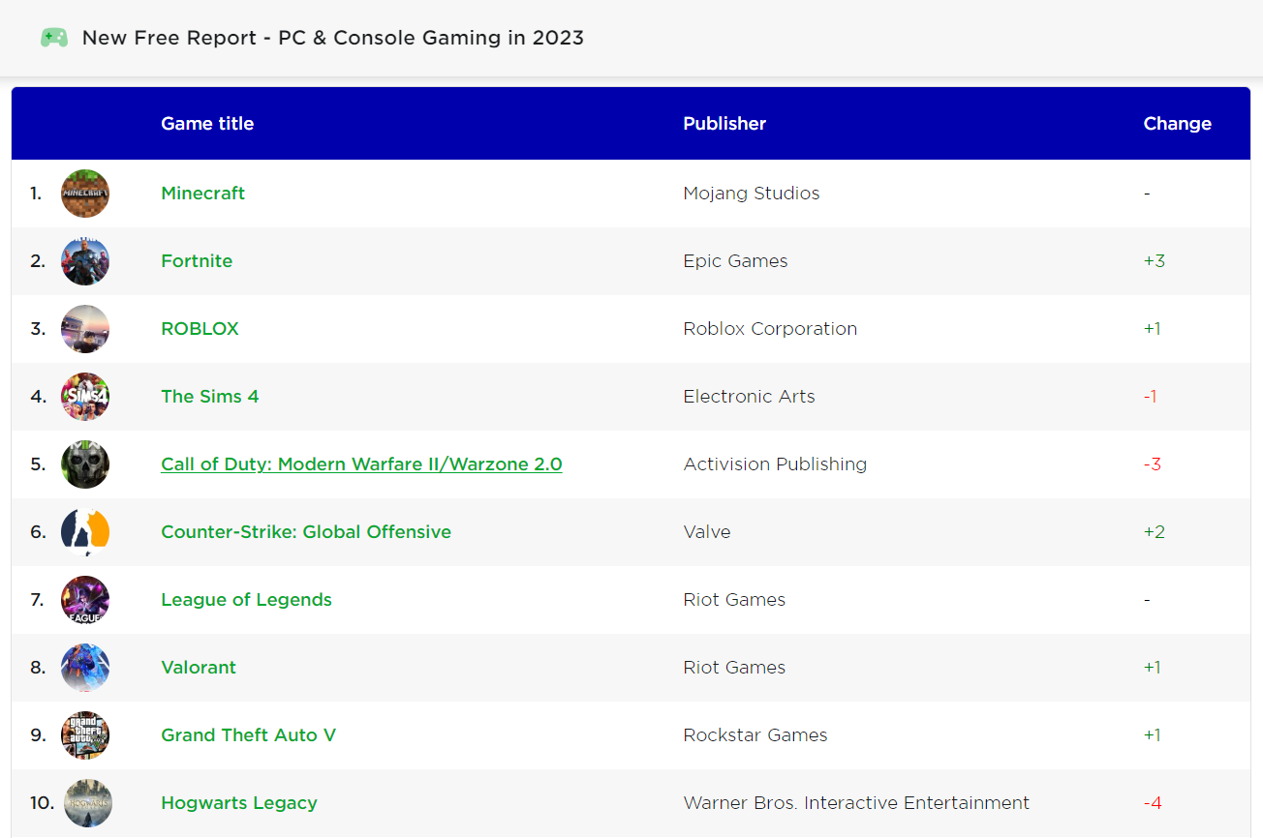

Figure - 2‑1: Most popular PC games of 2023

## Major issues in gaming apps and services

Although there are many local and worldwide services and programs created especially for video games, the majority of them provide capabilities that PC players already have access to. A player profile page, game mode, settings, new game downloads, system diagnostics, and logout are some of these features. These services often include choices for user login, user account creation, and account deletion. While playing, players can also take and edit screenshots, and the screen recording features allow them to record their games. Only a small number of services, however, are free to use, and those that are frequently have restrictions.

NVIDIA GeForce Experience, Rockstar Game, Steam, and Game Loop are a few well-known PC gaming programs that provide premium services. High service costs, installation requirements, the need for separate downloads for more services, and services evaluated according to cost are all characteristics that these apps have in common.

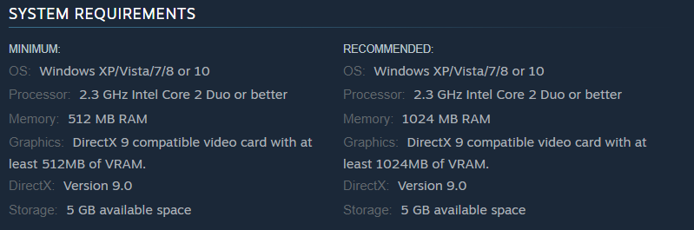

Figure - 2‑2: System requirements (On Steam)

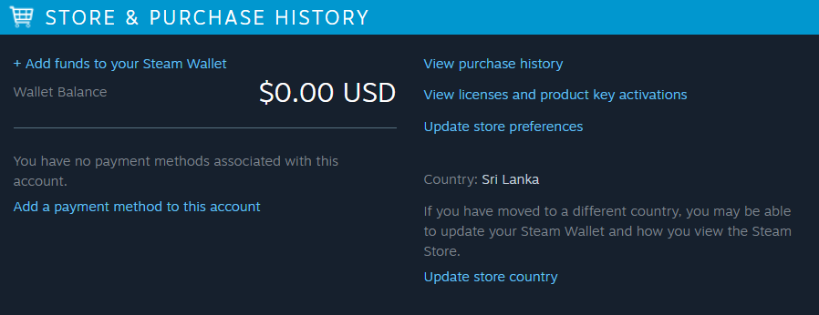

Figure - 2‑3: Store and purchase history (On Steam)

## Comparable Applications

### NVIDIA Geforce Experience

Gamers all across the world use NVIDIA GeForce Experience, a highly well-liked desktop programme. This computer programme offers users a number of functions, including the capacity to record videos, photos, and live streams and distribute them to others. The programme also makes it possible to optimize the computer's performance, particularly for PC gaming, enhances the user's Internet connection, and makes sure their drivers are up to date. Notably, NVIDIA GeForce Experience's optimization tools let the app optimize game settings, ensuring users have the greatest gaming experience possible. Overall, NVIDIA GeForce Experience is a thorough and user-friendly programme created to satisfy the particular needs of gamers, giving a variety of features to improve their gaming experience.

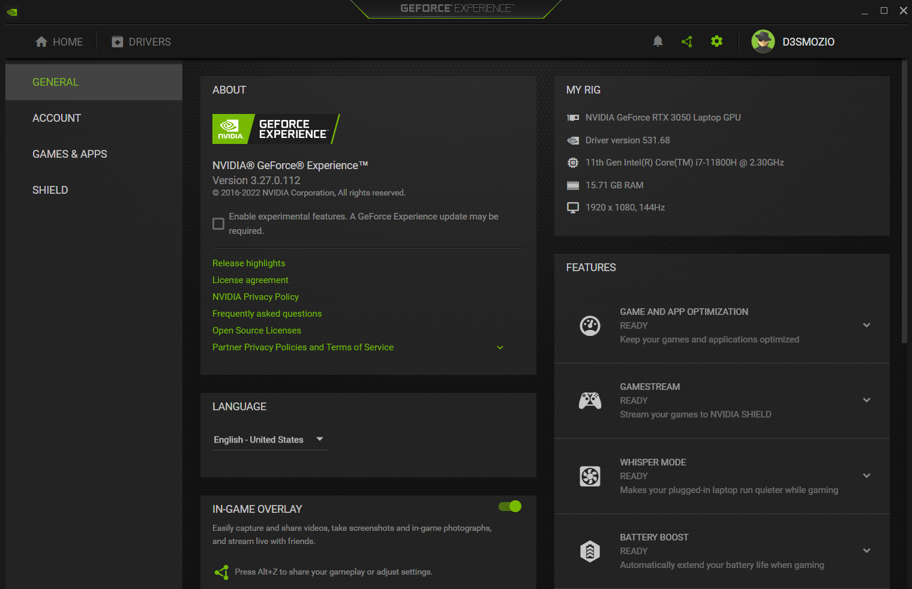

Figure - 2‑4: Interface of NVIDIA GeForce Experience Desktop Application

### Game - Loop

Another excellent programme, Game Loop, is mostly used to play mobile games on a PC. Game Loop gained popularity as a PC app thanks to the success of PUBG Mobile. Users can optimize their PCs for gaming, enhance their Internet connections, update their drivers, record films, images, and live streams, share them with friends, and change the settings for their games with the help of this programme. In addition, customers can use Game Loop, one of the services provided by this programme, to download mobile apps from the Play Store.

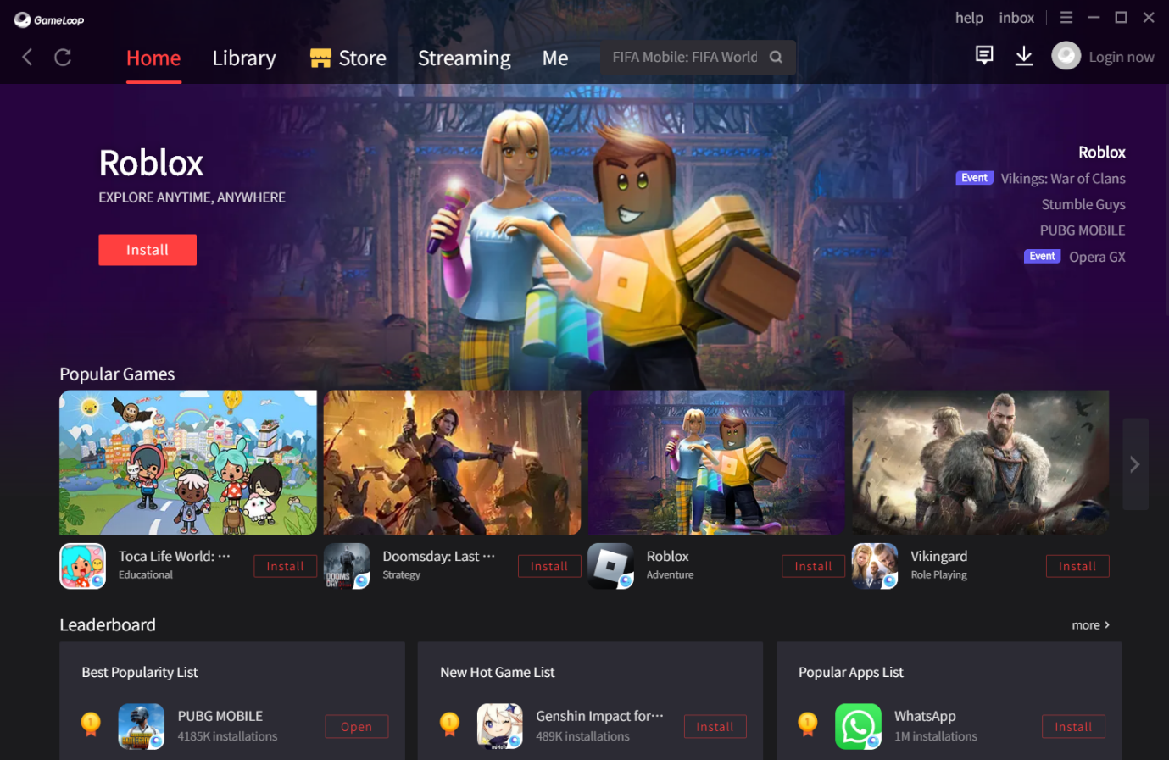

Figure - 2‑5: Interface of Game-Loop Desktop Application

### MSI – Center

A well-known desktop programme that serves gamers' and power users' needs is called MSI Centre. It gives users the option to personalize and enhance their MSI PCs, laptops, and accessories. The app offers a variety of features and functionalities in order to improve the user experience. Users may monitor and manage their system performance, temperature, and fan speed using MSI Centre. Additionally, it offers real-time system data on CPU, memory, and disc consumption. Users can use this application to maintain the functionality of their gadgets and make sure they are operating at their best.

Additionally, MSI Centre offers users a one-stop shop to personalize and customize their gadgets. The app includes a variety of customization options, such as RGB illumination, custom keyboard layouts, and settings specific to particular games. The user interface is simple to use and intuitive, making it simple for users to access the different capabilities offered and traverse the system. In general, the desktop MSI Centre programme is a crucial tool for gamers and power users to enhance the performance of their MSI devices and personalize them to their tastes.

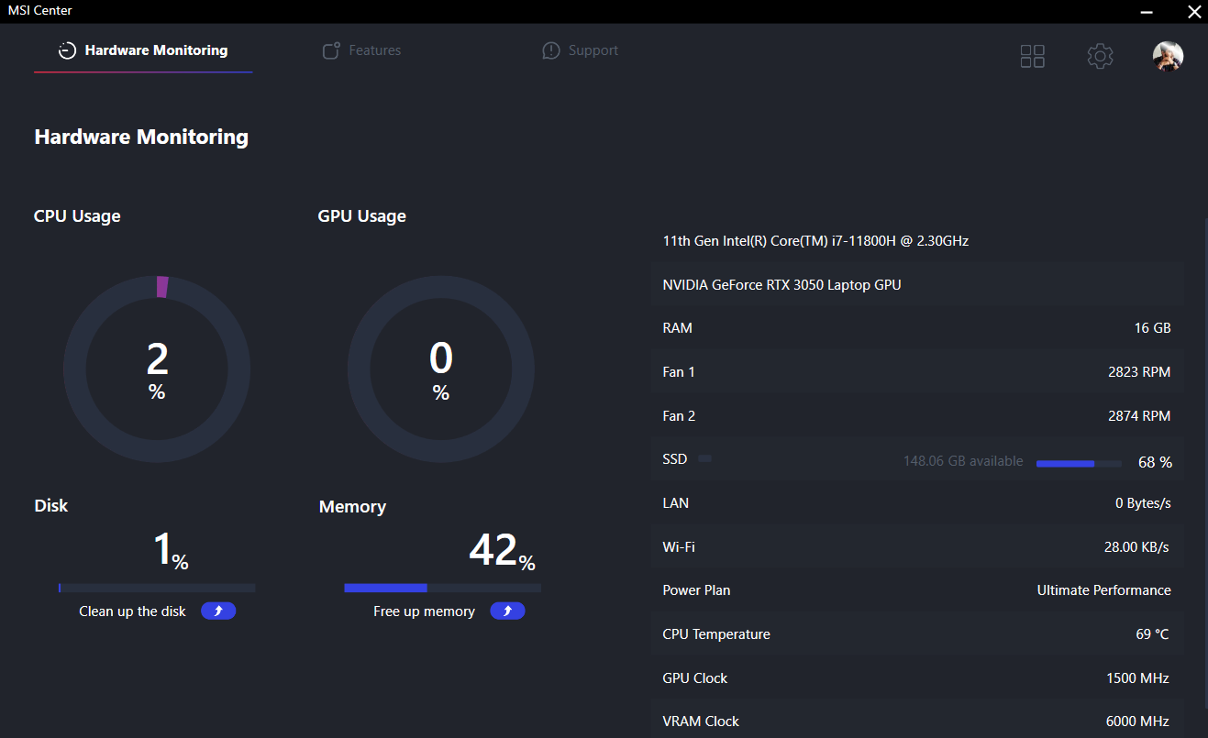

Figure - 2‑6: Interface of MSI - Center desktop application

## Computer–related health problems

Our daily lives now cannot function without technology, which has gradually rendered several professions entirely reliant on its use. Computer games are a fantastic illustration of this because they all feature missions and levels that demand the player to sit in front of a computer screen for an extended period of time. According to Tucker's (2019) list of the top 10 computer-related health issues, this can result in a range of health issues, such as musculoskeletal issues, visual issues, repeated stress disorders, headaches, obesity, stress-related illnesses, and laptop damage. use, sleep issues, hearing consequences of headphones, and elevated risk of blood clots.

Computer users frequently experience vision-related issues, which can be resolved by wearing glasses. Multitaskers, competent computer gamers, and regular users of a range of computer-related activities were shown to be more likely to have eye issues, according to Dong and Katbas (2020). Incorrect computer posture can also result in issues including hand numbness and muscular pain, as well as regular migraines brought by muscle strain or neck pain (YouTube, 2021). In addition to these factors, headaches can also be brought on by eye strain or vision issues brought on by computer screens' artificial illumination, which tricks the brain into producing less melatonin, a hormone that controls sleep cycles.

Users can focus better and block out background noise by wearing headphones while using a computer. However, if the sound is too loud, it could also be dangerous. When using portable media players, people frequently set the volume excessively high even when they don't need to hear the audio clearly. This increases the risk of noise-induced hearing loss. All of these issues demonstrate how regular computer use can have a negative impact on health.



Figure - 2‑7: Correct posture (Posture: Don't be a slouch! - spineuniverse)

## The importance of time management in life

### What is time management

The organization and control of one's time are referred to as time management. An effective time management system can assist people in planning their time between important tasks. Controlling one's time and energy is essential for efficient time management. People who manage their time can accomplish more in less time and with less stress. The goal of time management is to allocate as much time as possible to activities that will enable people to accomplish their goals more rapidly. People who are good at managing their time can spend more time on important tasks and less time on unimportant ones. Effective time management can boost performance and productivity. People can accomplish more in less time and effort by working more intelligently rather than harder. Prioritization, goal planning, and task delegation are necessary for effective time management. For enhanced time management, it is necessary to have stronger planning, decision-making, organization, and time management abilities.

Effective time management can enhance one's work-life balance in addition to the advantages listed above. Effective time management allows people to schedule time for their hobbies and personal lives, lowering the risk of burnout and raising overall happiness. As people are able to finish jobs more quickly and stress-free, time management skills can also boost job satisfaction. Additionally, time management skills can assist people in achieving their long-term objectives, such as professional or personal growth. People can make progress towards their goals by successfully prioritizing tasks and managing their time. Finally, better time management can also result in better decision-making abilities since people will know how their time is being used and will be able to make decisions that are well-informed (Sepharoth64, YouTube 2021).

### Advantages of effective time management

The benefits of effective time management are numerous for those who regularly use it. People may boost their productivity and do more things in less time by using time management skills, which frees up more time for personal growth and development. A better sense of success and fulfilment in life may follow from this. Additionally, effective time management can lower stress and anxiety, enabling people to approach both their personal and professional lives with more clarity and assurance. Additionally, it offers more time for leisure and self-care, which can enhance mental health and general wellbeing.

Additionally, having good time management skills might help people make better decisions since they have more time to think through and order their priorities. People can make better decisions and succeed more in both their personal and professional life if they have a strong sense of direction and purpose. Additionally, effective time management can improve work-life balance by enabling people to allocate enough time to both their professional and personal lives. Overall, this may result in a more contented and rewarding existence. It is important to remember that time management is a continual process that calls for ongoing focus and effort. It requires long-term cultivation as a habit rather than a quick remedy. People can attain their objectives more quickly and successfully by developing good time management skills, which will result in a more successful and meaningful life.

## Technologies Used

Artificial intelligence (AI), machine learning, and data preprocessing are among the technologies used in this research. Algorithms for machine learning are used to analyze data and learn from it, allowing the system to continuously improve. Machine learning requires the cleaning and conversion of data into a format that can be analyzed, which is known as data preprocessing. AI is utilized to build smart systems that are capable of reasoning and carrying out actions that normally call for human intelligence. Together, these technologies allow the system to analyze data and learn from it, enhancing its accuracy and performance over time.

### Artificial intelligence (AI)

Artificial intelligence (AI) is the term for computer intelligence that may be taught to replicate human behavior or reasoning. After being trained on a huge amount of data, AI models are developed using machine learning and deep learning approaches (Biswal, 2022). Statista projects that by 2025, the global market for AI software will be worth $126 billion. Gartner reports that in the last four years, there has been a 270% growth in the use of AI by businesses, with 37% of those utilizing it. By 2025, according to Servion Global Solutions, AI will control 95% of customer contacts. By 2020, the market for AI software is anticipated to expand by 54% yearly and reach a value of $22.6 billion USD (Biswal, 2022).

The world is currently making substantial attempts to use AI technology to streamline business operations. Some huge firms are still having difficulty using AI to its full potential, despite the fact that many of them are attempting. Leading businesses, for instance, use AI to carry out their jobs in a variety of industries, including the production of vehicles. AI has also been applied in industries like food production, education, and the manufacture of airplanes. Natural language generation, machine learning models, virtual assistants, decision management, AI-optimized hardware, deep learning platforms, robotics, automation, biometrics, and cyber security are a few examples of the several categories into which AI technologies can be divided. The researcher's main areas of interest in this situation are decision management and deep learning platforms. AI programs can be taught to use logic to make manual decisions. Deep learning models are capable of analyzing a person's personal data and rendering a variety of conclusions.

### Machine Learning Data Analysis Techniques

Machine learning and data analysis techniques have evolved into critical technology for a wide range of applications, including process data analysis and industrial automation. Several articles and studies on the topic have been published by researchers and practitioners, stressing the potential benefits of this technology.

Lampropoulos investigates the application of machine learning algorithms in spotting patterns in large data sets in their research piece titled (Artificial Intelligence, Big Data, and Machine Learning in Industry 2022). This method can lead to improved automated processes and more precise predictions, both of which are critical in today's market (Lampropoulos, 2022).

In their essay "Machine Learning Advances and Opportunities for Process Data Analytics 2019," Qin and Chiang address the use of machine learning techniques in process data analytics. They demonstrate how these techniques can be used to find patterns and trends in large amounts of data, allowing for more efficient and effective decision-making (Qin & Chiang, 2019).

Finally, Chin et al.'s essay "Machine Learning and JavaFX 2019" shows how machine learning may be used in conjunction with JavaFX to create sophisticated data analysis tools. This technology helps analysts and engineers to see and analyze complicated data sets quickly and simply, discovering patterns and trends that traditional methods may overlook (Chin et al., Machine learning and JavaFX 2019).

In conclusion, the combination of machine learning and data analysis approaches has shown to be a potent tool for industry and other applications. Researchers and practitioners are constantly looking for new ways to improve the usage of these technologies.



Figure - 2‑8: Machine Learning overview

### Data Processing Techniques Overview

Due to the massive amounts of data that businesses produce and modify; data processing techniques are a crucial component of the current corporate landscape (Hasan et al., 2020). These strategies cover a variety of procedures for gathering, arranging, and interpreting data in order to generate insightful conclusions and assist in decision-making. Data transformation involves turning data into a standardized format appropriate for analysis. Data cleaning involves locating and removing flaws or inconsistencies in data collections.

Additionally important methods for data processing are data aggregation and summarization, which enable huge amounts of data to be broken down into more comprehensible formats. A useful method for presenting data in a form that stakeholders can comprehend is data visualization (Golfarelli & Rizzi, 2019). It is also possible to analyze and understand data using data mining and machine learning techniques, which enables the finding of hidden patterns and relationships that might not be immediately obvious.

Last but not least, data processing methods are crucial to any organization that relies on data, and their proper use can yield insightful information about how decisions are made.



## Research Gap

The results of the conducted literature review indicate that computer gamers can considerably profit from the services provided by the current applications that are available for their daily work. With the aid of these tools, players can take part in video games precisely. There is now no distinction between services for casual players and those who might be gaming addicts. Therefore, using a personal details AI analyzer can offer a more modern and useful remedy for those suffering from video game addiction. The data would be analyzed by such an analyzer, which would then carry out the most effective time plan for the computer gamer.

Notably, this time management tool is helpful for everyone who wants to manage their time well, not just those who struggle with video game addiction. A service that offers guidance on how to use a computer correctly is also available. In section 2.4 of the review, four comparable systems with different functionalities are discussed. The NVIDIA GeForce Experience app and the Game-Loop software are comparable in that they offer similar functions. These programs might offer possibilities to download new games via NVIDIA GeForce Experience and GameLoop, as well as services that keep drivers current and optimize gaming settings. However, as mentioned in the introduction and research review, these solutions might not be able to help people who are addicted to video games. The CGM personal information service has been made available as a solution to this problem. This service employs an AI analyzer to look over user information and figure out the ideal timing for computer gamers. The player is able to successfully manage their daytime activities as a result. The service also offers instructions on how to operate a computer correctly. In essence, CGM can analyze machine learning data to evaluate the personal details of the computer gamer and offer the player a suitable time management solution. A Player Achievements page, a Screen Capture option, a Video recording capability, and email notifications for time-based activity hours are just a few of the exciting features that CGM offers.

The literature research concludes that computer gamers can gain a lot from current applications that provide services for their daily needs. For those who are addicted to video games, there is a need for a more practical answer. By analyzing data, implementing the most effective timing strategy for the computer player, and informing the gamer via a notification indicator, the use of a personal details AI analyst can offer such a solution. Such a solution is provided by the CGM personal information service, which evaluates personal information using machine learning data analysis and delivers a suitable time management tool. Additionally, CGM provides a number of unique features that might help players manage their time well.

Table - 2‑1: Comparison of the CGM with existing systems

|  |  |  |  |  |  |
| --- | --- | --- | --- | --- | --- |
|  | **NVIDIA GeForce Experience** | **Game Loop** | **Steam** | **MSI**  **Center** | **(CGM)** |
| * Capture and filter Screen Shots during gaming. | ✓ | ✓ | ✓ | × | ✓ |
| * Screen recording during gaming | ✓ | ✓ | ✓ | × | ✓ |
| * Gamer achievements page. | ✓ | × | ✓ | × | ✓ |
| * New games Downloads | ✓ | ✓ | ✓ | ✓ | × |
| * Optimize PC for gaming | ✓ | ✓ | × | × | ✓ |
| * Enhance Internet connections | ✓ | × | × | ✓ | × |
| * Keep system drivers up to date | ✓ | × | × | × | × |
| * Develop time management packages | × | × | × | × | ✓ |
| * FPS Counter | ✓ | ✓ | ✓ | ✓ | ✓ |
| * Enable Gaming Mode (Power plan) | ✓ | ✓ | ✓ | × | ✓ |



# Market research and feasibility study

Market research and feasibility studies are two significant components of the finished project that are covered in this chapter. By using a variety of data collection techniques, market research comprises selecting the demographic sample and gathering information on end-user experiences. A questionnaire was utilized for this aim, and a sample of mostly computer and video game users who were chosen based on age and gender. Probability sampling was utilized with stratified sampling as the sampling strategy, and the chosen sample was representative of the entire population. The information gathered from the questionnaire is arranged appropriately. The feasibility study, on the other hand, is carried out during the preliminary design stage of the planning phase to ascertain whether the proposed project is feasible by researching and outlining the financial, technical, resource, time, and risk factors. In order to assess the project's viability, this section tries to provide an outline of the feasibility analysis process.



## Market research

### Results of the questionnaire summarized

* Gathered information about gender

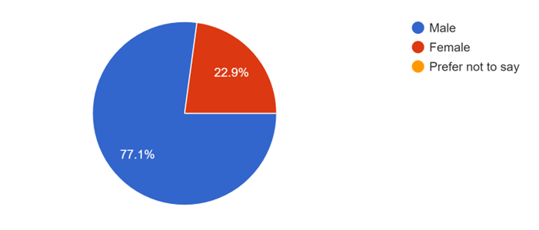

Figure - 3‑1: Questionnaire-Gender

This pie chart displays the gender-specific aggregated data (Figure 3-1). It demonstrates that the sample contains mostly male and very few females.

* Age information gathered

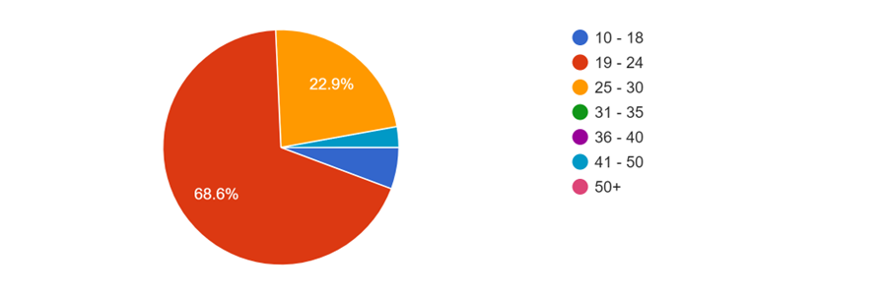

Figure - 3‑2: Questionnaire-Age

A pie chart showing the age information in relation to the data gathered is shown in (Figure 2-10). The age range between 19 and 24 is the largest, whereas the age range between 41 and 50 is only marginally larger.

* based on user comments, information about game app preferences

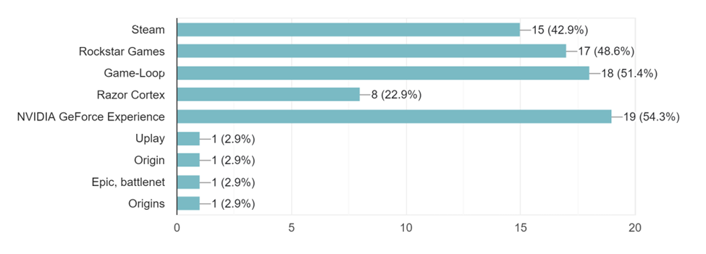

Figure - 3‑3: Questionnaire-Information of gaming app

(Figure 2-11) presents a pie chart showing the distribution of age data gathered. The age range of 19 to 24 has the biggest representation, while the age range of 41 to 50 has a low proportion. Additionally, depending on the input gathered, a data table displaying preferences for gaming applications is shown in Figure 2-10. According to the research, most users enjoy the NVIDIA GeForce Experience gaming platform. The least popular gaming apps were those from Uplay, Origin, Epic, Battle.net, and Origins.

* Information about the addiction to video games

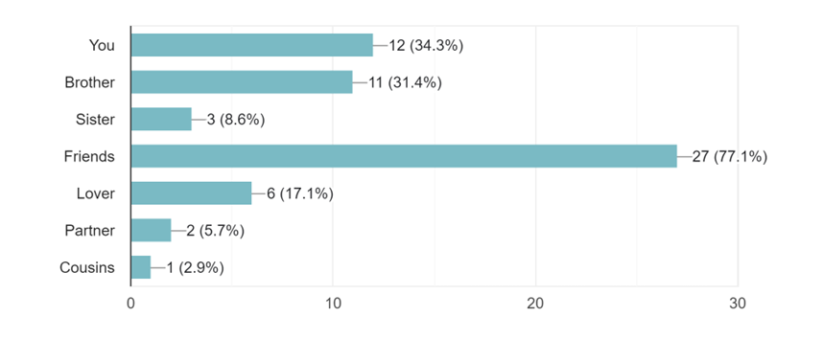

Figure - 3‑4: Questionnaire-Game addiction

(Figure 2-10) which lists the number of respondents' friends who are hooked to video games, contains information about video game addiction.

* Three potential treatments for computer gaming addiction have received feedback.

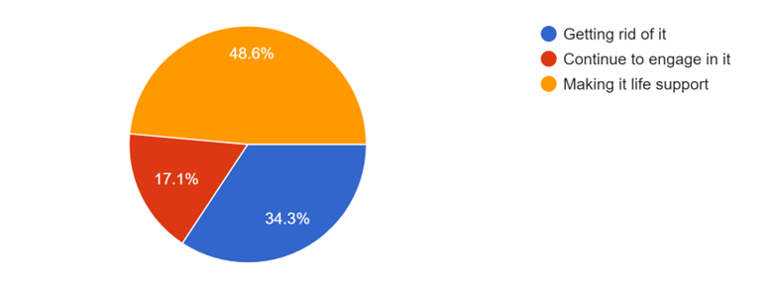

Figure - 3‑5: Questionnaire-Feedback of game addiction

(Figure-13) shows feedback statistics as a whole for three possible cures for video game addiction. The majority of people prefer to make computer video game addiction a pillar of their lives, according to the opinions we received. A very small percentage of persons have expressed a desire to cease this behavior.

* The answer to the question of whether time management techniques learned while playing video games can help people thrive in life.

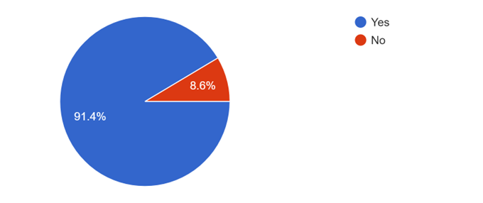

Figure - 3‑6: Questionnaire-Time management practice

(Figure 2-14) emphasizes how time management abilities may be used to succeed in life while playing video games. The statistics showed that the majority of respondents thought it was possible.

* Observations on the demand for a time management desktop application with video game playing.

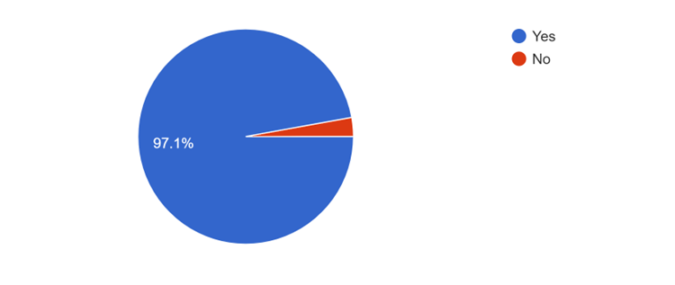

Figure - 3‑7: Questionnaire-Comments about CGM application

The pie chart in (Figure 2-13) satisfies the need for a desktop application that makes it easier to manage your time when playing video games. The vast majority of responders said they agreed.

* Comments on the qualities that such a platform should have

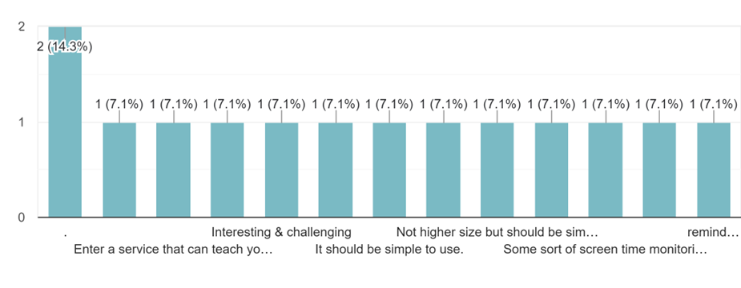

Figure - 3‑8: Questionnaire-Characteristics

## Feasibility study

### Financial feasibility

The CGM Project application is available for free download and installation. Since multimedia data cannot be transmitted, the programme has comparatively low bandwidth requirements. The programme complies with free software standards and doesn't impose any costs on potential users. Since the researcher currently offers these services, no maintenance or error-repair duties are necessary. Without placing a financial strain on the users, the project aims to increase interest in particular video games among computer game fans and addicts. Computer players can play video games and save the rest of their time for other pursuits by effectively managing their time. These elements demonstrate the CGM project's financial viability.

### Technical feasibility

CGM is a desktop application that was created utilizing a range of software and hardware.

These software's:

* IntelliJ
* Adobe Illustrator
* MySQL Workbench for database.
* Unreal Engine
* Adobe Photoshop
* Microsoft word
* Microsoft Project
* Notepad
* Diagram Drawing Tools (Microsoft Project, Draw.IO, ProjectLibre)
* SceneBuilder
* Google Chrome
* midjourny image designer
* Just Color Picker
* Trello

CGM was created using the programming languages Java, JavaFX fxml, and SQL. These technologies are all open-source and manageable with the appropriate technical skills. These technologies have been implemented in accordance with the CGM development timeline. Every technology is available for free, and the necessary technological abilities can be regulated. These technologies' ease of use during implementation and the timing for product development have also been coordinated. Any development task can be easily completed thanks to the provided free services. CGM is technologically viable because it does not use any multimedia.

### Resource and Time feasibility

the supplies required for the CGM,

* Programming device (using a laptop or personal computer)
* Programming tools (available for free)
* Database workbench (available for free)
* A working Internet connection(available)

As a result, the CGM has the required resource feasibility.

Trello was used to manage project schedules effectively. Individual developers and business owners can track their progress and set deadlines for their projects using this project management tool. Tasks might be prioritized and finished on time using Trello. Overall, by offering a streamlined and organized approach to project management, adopting Trello dramatically increased timeliness for solo projects.

### Risk feasibility

Risk potential can speak in a variety of circumstances.

* The threat posed by a size
* Application size as measured by the number of lines of code: Because this is a desktop application and the functionalities require multiple lines of code, the download size will range from 50 to 100 MB. This is because there are also other elements like graphics and animation.
* Calculated product volume divided by total programs: The script runs across the computer as a single application.
* Size of the database that was created or used by the programme: The database won't expand past MySQL Workbench's capacity.
* The amount of reused software: CGM will add some functionality by combining a few libraries with the main logic employed throughout the project.
* Liability risk
* Validity of the delivery window: Due to the project's 31-week length, a number of CGM due dates and deliverables are planned one after another. coding and design. When the time is right, this will be finished.
* The following parties are at risk: Stakeholders can be classified into two fundamental types. both those who play computer games and those who are computer game addicts. This application has been filed in its full for these two parties.
* Highly educated user base Easy to use: The difficulty involved in creating CGMs is comparatively low. Usability is greatly improved by assisting documents and streamlining GUIs.
* Environmental risks to development.
* Software project management tool: Microsoft Project will be used as the main project management tool.
* Planning and analysis software: CGM requires design software. Build databases with Draw IO. ProjectLibre: Create a Strategy.
* The technical risk.
* Is new technology needed? All existing technologies are mature and sufficiently aged (yet not obsolete).
* Is it necessary to create new algorithms, input, or output technologies to satisfy the system requirements: In order to create a time-management tool tailored for computer gamers, CGM may collect information about them. AI technology is used in that process.
* Social and Legal Feasibility
* CGM is provided to developers as a free tool. The researcher works hard to benefit society in this desired way.

It may be said that the CGM project satisfies the criteria for financial, technical, resource, time, and risk feasibility after conducting a full feasibility analysis. Due to the fact that the project provides its services without charging a fee and doesn't call for any maintenance or fault-repair work, it is financially feasible. It is technically possible to build the desktop application using open-source hardware and software. The project requires few resources and using Trello to handle it is more efficient in terms of timeliness. Project-related risks have been discussed and minimized. The initiative is also ethically and legally viable because it gives developers a free tool that has a positive societal impact. Overall, the feasibility study has demonstrated the viability and value of the CGM project.

# Methodology

The methodology chapter of the paper includes a thorough description of the system's design, data collecting and analysis, and the procedures followed to design, implement, and test its systems. The report explains the project's design process and analyses the technique utilized to create the system. In-depth details on system design and methods for data collection and analysis are provided in this chapter. The study goes into great detail on every area of application testing and implementation.

## Software development methodology

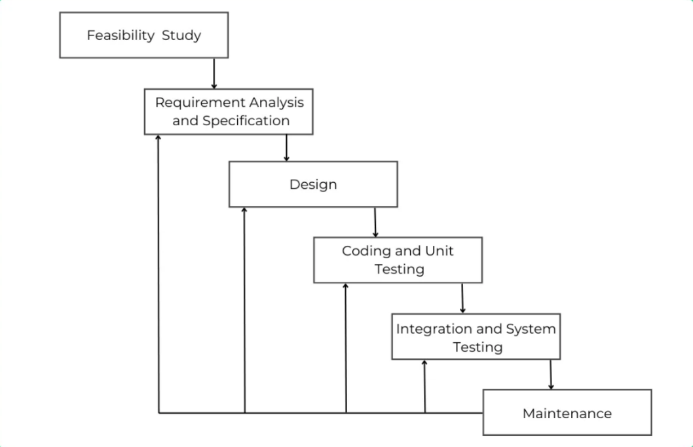Iterative waterfall methodology is used to create the finished system because of how adaptable it is. The ability of both the customer and the developer to add new features and enhance the design at any stage of the process justifies utilizing the agile method for this system. By utilizing development technologies as it happens, this leads to more efficient software development. Testing the system from beginning to end is also beneficial for the developer. A flowchart shows how the iterative waterfall methodology works. It starts with requirements collecting to see if the system can be implemented. System maintenance and the processes of requirements analysis, specification, design, coding, unit testing, and integration testing are ongoing. The recursive waterfall model is simpler to understand and apply but lacks the feedback loop from one step of the error coupling mechanism to its predecessor. This methodology is the most popular one for software development and can result in an app without any bugs.

Figure - 4‑1: Iterative waterfall methodology (2023)

## Planning

To determine the viability of the created CGM desktop application, a thorough feasibility analysis was conducted during the project's initial stage. The study's objectives were to examine the existing state of relevant systems, identify subject matter experts, and pinpoint the best available technology. A literature review was also done to find out the approaches applied in earlier research on the topic of the project.

A thorough evaluation of the CGM application was carried out during the ensuing time, cost, and resource planning process. In this procedure, jobs that required considerable budget and resource commitments were identified. To clarify the project's deliverables and determine its scope, a work breakdown structure was also developed. An overview of the project's schedule and tasks was created using a Gantt Chart in order to translate the plan into an action timetable. Additionally, a Trello board was employed to expedite project administration and encourage team member communication.

In general, the goal of the original project phase was to lay a strong foundation for the creation of the CGM application. The team was able to anticipate potential issues and create efficient ways to reduce risks and guarantee the project's successful completion through a thorough feasibility analysis and cautious planning.

## Gathering and Analyzing Requirements

Two techniques were used: primary data collecting and secondary data collection, in order to gain a thorough grasp of the requirements for the produced system. Sending questionnaires to the target audience was the main way used to collect data with the intention of learning more about the specific features they would want to see in the system. In order to meet the needs of the consumers, it was essential to determine the major functionality and technical requirements using the data gathered using this method.

On the other hand, the secondary data collecting strategy required reading through a variety of sources, including articles from newspapers, magazines, and websites. With the help of this technique, it was possible to discover industry best practices as well as get insightful knowledge about current systems and their characteristics. The system development process was greatly aided by the requirements acquired from both primary and secondary data sources, which resulted in the addition of features that made the suggested solution both technically viable and necessary for computer gamers' daily life.

## Design

The goal of the CGM desktop application, which has now been fully developed, is to make it simpler for players to manage their time while partaking in their favorite hobbies. The Java and JavaFX coding languages were used to implement the project utilizing the IntelliJ IDEA framework. Adobe Photoshop was used to create the visuals and animations, and SceneBuilder was utilized to create the user interface. Additionally, the database management system MySQL Workbench was utilized to store Player data as well as other information. The software uses machine learning and AI-specific features to increase its effectiveness and utility. The suggested programme has a very user-friendly user interface that is simple to use, and the services it offers are straightforward and simple to obtain. Players can select the time management package that best satisfies their individual needs from the program's default time management package, which is customised to meet their unique needs. The application is a comprehensive tool for controlling every part of the game because it contains a player accomplishments page, screen capture, fps counter, hardware monitoring, and game mode changing functions.

One of the unique features of the proposed application is its focus on educating players on how to use their computers correctly, thereby reducing the risk of damage or malfunction. The app is designed to provide gamers with a seamless experience, allowing them to focus on their games while ensuring they use their computer systems efficiently and effectively. Overall, the proposed application represents a significant step forward in the field of computer game management and is expected to be of great benefit to players trying to manage their gaming activities more effectively.

The design and construction of the application are displayed in UML diagrams created during the design phase.

### UML Diagrams

From design through implementation, a software application goes through various stages. Creating diagrams in the Unified Modelling Language (UML) is a crucial stage in the design process. UML diagrams make it simpler to comprehend the design and functionality of the programme by providing a graphical depiction of a system's structure, behavior, and interactions. In order to verify that the design of the programme and the interaction with the user were clear and clearly defined, UML diagrams were developed while designing the proposed application.

UML diagrams offer a thorough understanding of the system architecture, its constituent parts, and their interrelationships. Before the design is put into practice, this aids in identifying potential issues or mistakes. Since the application is developed in accordance with the requirements and adheres to the specified quality standards, the usage of UML diagrams ensures this.

* Use case diagram
* ER diagram
* Class diagram

## Implementation and Testing

This chapter explains how to use an iterative waterfall methodology to conduct continuous testing of the planned system development. This method guarantees the development of error-free, useful programs.

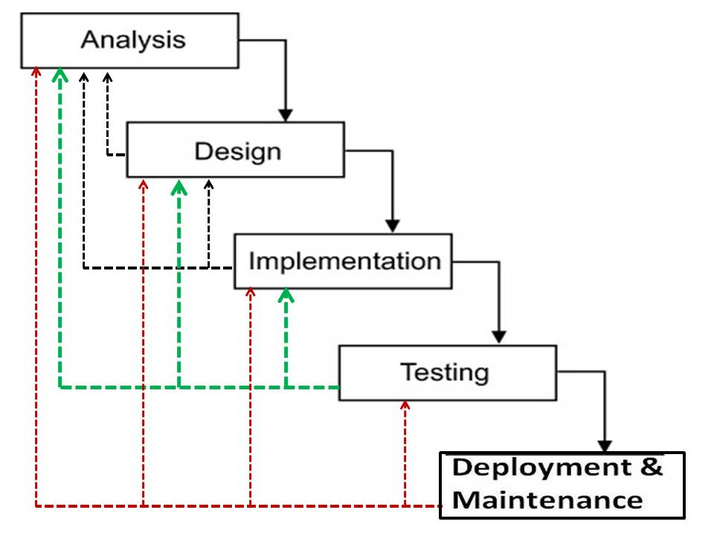

Figure - 4‑2: Iterative waterfall methodology testing (Software process)

The aforementioned diagram (Figure 2-18) shows the iterative waterfall methodology's testing steps. These processes will be used to test the proposed project.

# Design and Testing Artefacts

Along with pertinent tools, technologies, and code samples, a whole development approach for the CGM application is described in this part. There is also a brief explanation of how each unit was tested.

## Design Artefacts

The core of the CGM application is created in the IntelliJ IDEA IDE using the JavaFX programming language, and the MySQL Workbench database is utilized to store user data and carry out all database activities. The main tools used to create the UI for the app were SceneBuilder, Just Colour Picker, and Adobe Photoshop, all of which contributed to its improved quality and usability. The FXMLLoader class was used to load the IntelliJ IDEA UI design into the JavaFX application. SceneBuilder was largely used to construct the IntelliJ IDEA UI design. With the help of Adobe Photoshop, the UI design was improved, and the Just Colour Picker tool was used to improve the app's colour scheme. The combination of these tools helped to make the user interface (UI) of the programme both aesthetically beautiful and approachable.

### Management of User Accounts

To access all features, each user must create a user account. These users can log into the system using different accounts(Figure 2-19)(Figure 2-20). The user must create an account by providing the necessary information if they don't already have one. Before logging in, each input is verified, and the user is then registered. The database connection should be made at this point. The developer initially downloaded and installed MySQL Workbench on the PC in order to store data in MySQL Workbench using JavaFX in IntelliJ IDEA. Then, in MySQL Workbench, create a new database and build a table with the necessary columns to hold the data. The MySQL Connector library can be included as a project dependency in the JavaFX project in IntelliJ IDEA. The developer utilized the JDBC driver and database credentials to connect to the MySQL database. Data is inserted into the database using SQL statements, and the Prepared Statement class can be used to create statements containing placeholder values for data. Then, SQL statements can be run using the execute Update () method. This procedure made use of the MySQL Connector/J library, which is the official JDBC driver for MySQL(Snippet 1).

Snippet - 5‑1: Database Connection

public class DatabaseConection {

public Connection databaseLink;

public Connection getConnection() {

String databaseName = "desmodb";

String databaseUser = "root";

String databasePassword = "Root";

String url = "jdbc:mysql://localhost:3306/" + databaseName;

try {

Class.forName("com.mysql.cj.jdbc.Driver");

databaseLink = DriverManager.getConnection(url, databaseUser, databasePassword);

} catch (Exception e) {

e.printStackTrace();

e.getCause();

}

return databaseLink;

}

}

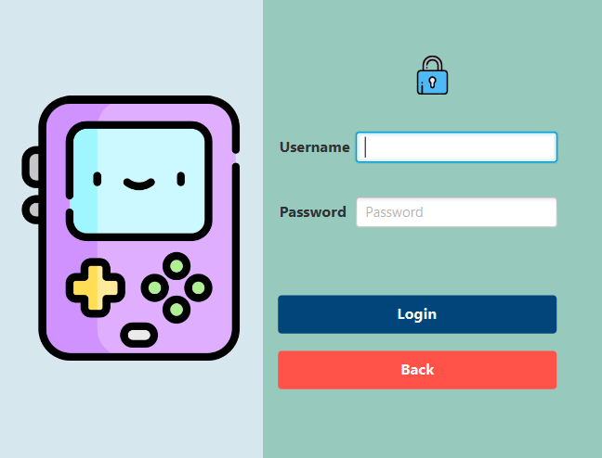

Figure - 5‑1: User interface(Login)

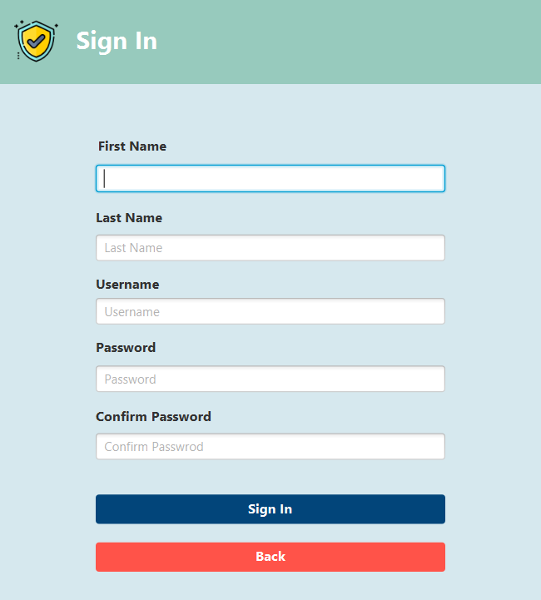

Figure - 5‑2: User interface(Sign in)

### Management of Home Page

A player is taken to the CGM home screen after logging into their account, where they may access all of the functions of the app, including Home, Game Mode, Hardware Monitoring, Capture, FPS Counter, Achievements, and Time Management Package. An image of the user interface for the CGM home page is shown to give users a visual representation of the interface(Figure 5-3)(Figure 5-4).

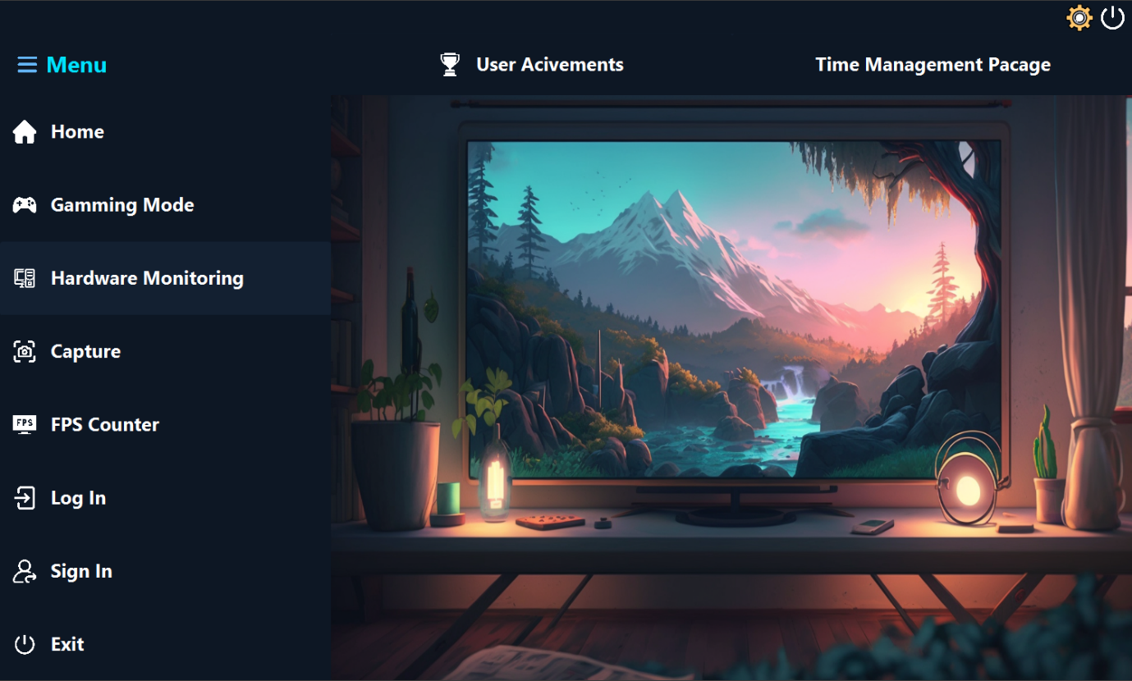

Figure - 5‑3: User interface(Home page)

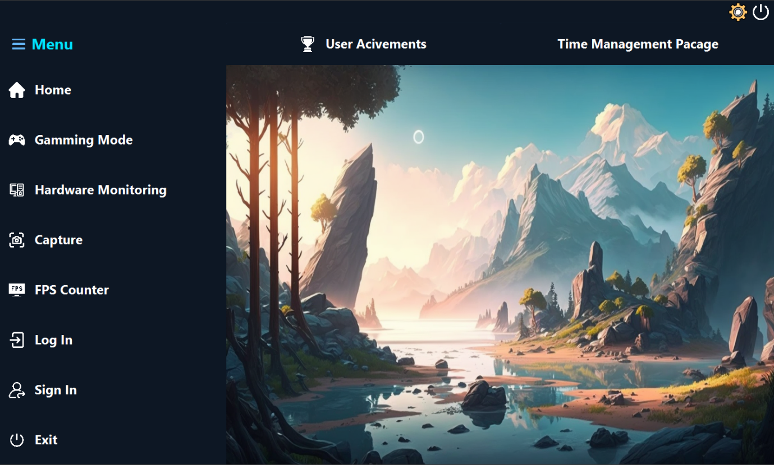

Figure - 5‑4: User interface(Home page)

As seen in the photos provided, the CGM home page contains a number of buttons that call up particular actions within the application. Each button's functionality is enabled by executing the button events with a piece of code. The snippet of code outlines the steps that should be carried out when a button is clicked.

CgmMainPageController must be called in order to confirm that the button created in cgmMainPageUI.fxml is active. To accomplish this, add a "fx:controller" attribute to the root element of the FXML file and set it to the controller class's fully qualified name. The action that will be taken when the button is clicked should be represented by a method in the controller class. The @FXML annotation can be used to mark this function as a handler for an FXML-defined UI element. The handler method will be run when the button is clicked, enabling the necessary action to be taken.

The cgmMainPageUI.fxml file creates the EXIT button on the CGM home page, and the cgmMainPageController implements its functionality. The exitApplication() method in the controller is called when the user presses the EXIT button, causing an event to be raised. The code for this procedure closes the programme window and releases any resources that the application has been using. Depending on the programming language and framework used to construct the application, the method's implementation specifics may change. Overall, the EXIT button gives users a practical way to end a programme and free up system resources(snippet).

Snippet - 5‑2: Button set on action

public void ExitButtonOnAction(ActionEvent event){

Stage stage = (Stage) btnExit.getScene().getWindow();

stage.close();

}

Snippet - 5‑3: Button FXML code

</Button>

<Button fx:id="btnExit" alignment="BASELINE_LEFT" graphicTextGap="15.0" mnemonicParsing="false" onAction="#ExitButtonOnAction" prefHeight="100.0" prefWidth="350.0" stylesheets="@../../../CGM_CSS/CGM_Home.css" text="Exit" textAlignment="JUSTIFY" textFill="WHITE">

### Management of Gaming Mode

On the CGM main page, there is a feature called the "Gaming Mode" button. Users can change between different game modes. The button is created using button events, and the matching code function is linked to it. The action that the button causes when it is clicked modifies the game mode. enables users to easily access the computer's power menu and switch to the preferred power choice. For PC gamers who wish to customize their gaming experience based on their tastes and hardware capabilities, this option is helpful. It is possible to set the game mode to balance performance and quality or to prioritize one over the other. Users can personalize their game experience using this function, which improves the overall gaming experience. The following diagram illustrates how the button and the function work.

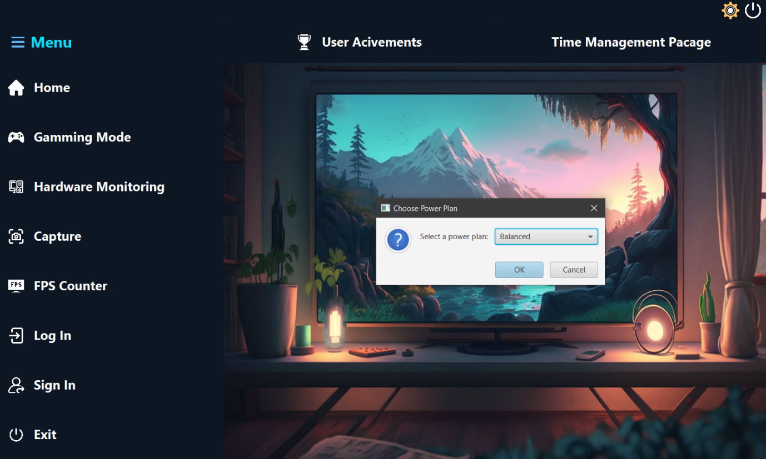

Figure - 5‑5: User interface(Gaming mode)

When a user switches to a different gaming mode by selecting the "Gaming Mode" button on the CGM home page, the system replies by showing a message to the user via a JOptionPane. This notification informs the user that the gaming mode has been successfully adjusted. The message appears as a pop-up dialogue window, with a "OK" button that the user can click to close it. The user is therefore alerted of the successful change of gaming mode. The system achieves this feature by utilizing appropriate code in the CGM home page controller, which listens for the button event, updates the database, and then shows the message to the user via the JOptionPane.

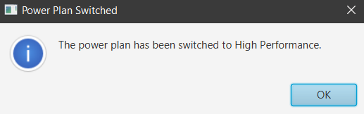

Figure - 5‑6: User interface(Joption pane)

The following code snippet demonstrates how the built application's game mode feature is implemented. To activate game mode functionality, the code uses JavaFX button events.

Snippet - 5‑4: Gaming mode

btnGmaingMode.setOnAction(event -> {

// Define the available power plans

Map<String, String> powerPlans = new LinkedHashMap<>();

powerPlans.put("Balanced", "381b4222-f694-41f0-9685-ff5bb260df2e");

powerPlans.put("High Performance", "8c5e7fda-e8bf-4a96-9a85-a6e23a8c635c");

powerPlans.put("Ultimate Performance", "e9a42b02-d5df-448d-aa00-03f14749eb61");

// Create a ChoiceDialog to let the user choose a power plan

ChoiceDialog<String> dialog = new ChoiceDialog<>("Balanced", powerPlans.keySet());

dialog.setTitle("Choose Power Plan");

dialog.setHeaderText(null);

dialog.setContentText("Select a power plan:");

URL cssFile = getClass().getResource("CGM_CSS/choice-dialog.css");

if (cssFile != null) {

dialog.getDialogPane().getStylesheets().add(cssFile.toExternalForm());

}

The game mode button is created in cgmMainPageUI.fxml as shown below.

Snippet - 5‑5: Gaming mode button FXML

</Button>

<Button fx:id="btnGmaingMode" alignment="BASELINE_LEFT" graphicTextGap="15.0" mnemonicParsing="false" prefHeight="100.0" prefWidth="350.0" stylesheets="@../../../CGM_CSS/CGM_Home.css" text="Gamming Mode" textFill="WHITE">

### Management of Hardware Monitoring

The application displays the performance of the user's device when the user hits the Hardware Monitoring button on the CGM home page. Oshi, a third-party library that offers system information for many operating systems, is used to perform this function. The HardwareMonitorController class implements the code for the hardware monitoring functionality, which uses the Oshi library to gather system information such as CPU consumption, memory usage, and disc usage. This data is presented to the user in the form of charts and graphs generated with the JFreeChart package. By pressing the Refresh button, the user can also opt to refresh the monitoring data. Overall, the hardware monitoring tool provides the user with real-time performance statistics about their device, allowing them to make informed system optimization and maintenance decisions.

The CGM application's hardware monitoring interface displays real-time hardware performance metrics such as CPU use, GPU temperature, and RAM usage on an Anchor pane with a graph. It helps gamers optimize the performance of their systems and gives a user-friendly and interactive approach to check their hardware performance.

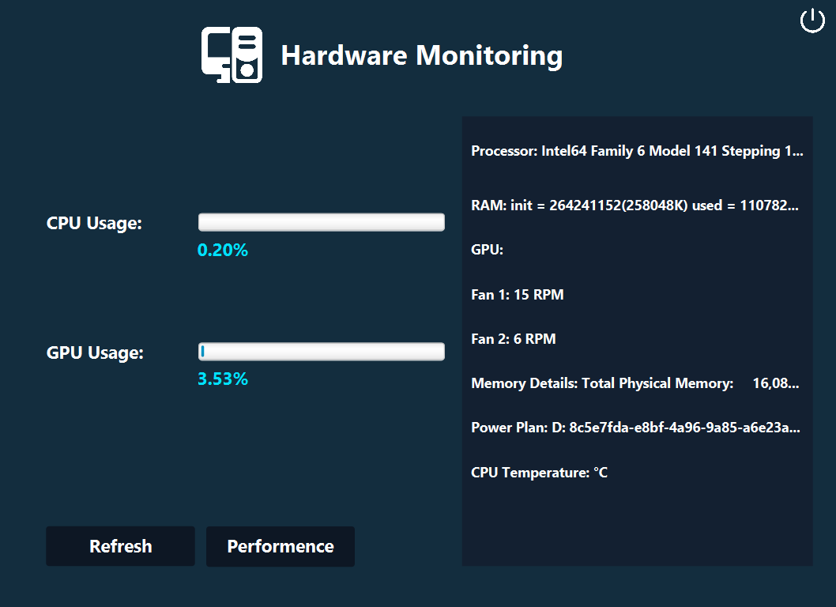

Figure - 5‑7: User interface(Hardware monitoring)

The HardwareMonitorController in the CGM programme implements the hardware monitoring interface. This controller is in charge of displaying hardware performance data in the application's user interface on an Anchor pane. The controller gets real-time performance data from the system, such as CPU utilization, GPU temperature, and RAM usage, and changes the hardware monitoring graph accordingly. The hardware monitoring graph displays a visual depiction of a user's system's performance, which is useful for gamers looking to optimize their system's performance for the optimal gaming experience. The HardwareMonitorController provides a user-friendly and interactive mechanism for users to monitor the operation of their system.

Snippet - 5‑6: Get updated hardware details

private void updateHardwareMonitorData() {

// Get the hardware monitoring data and update the user interface components

double cpuUsage = getCPUUsage();

Platform.runLater(() -> {

cpuProgressBar.setProgress(cpuUsage / MAX_CPU_USAGE);

cpuLabel.setText(String.format("%.2f%%", cpuUsage));

});

double memoryUsage = getMemoryUsage();

Platform.runLater(() -> {

memoryProgressBar.setProgress(memoryUsage / MAX_MEMORY_USAGE);

memoryLabel.setText(String.format("%.2f%%", memoryUsage));

});

}

Snippet - 5‑7: Get cpu usage

private double getCPUUsage() {

// Use JMX to get the CPU usage

// Implement your own logic here

double cpuUsage = osBean.getProcessCpuLoad();

// Convert the CPU usage to a percentage

cpuUsage = cpuUsage * 100;

// Format the CPU usage to two decimal places

DecimalFormat decimalFormat = new DecimalFormat("#.##");

cpuUsage = Double.parseDouble(decimalFormat.format(cpuUsage));

return cpuUsage;

}

HardwareMonitor.fxml is used to design the user interface for the HardwareMonitorController, which shows real-time hardware performance data in an Anchor pane of the CGM application. This file provides the hardware monitoring interface's layout and design features, such as graphs and labels for CPU utilization, GPU temperature, and RAM usage. This file is used by the HardwareMonitorController class to construct and show the application window's user interface. This method separates UI design from application logic, making the interface easier to manage and upgrade in the future.

Snippet - 5‑8: Hardware monitor FXML

<AnchorPane maxHeight="-Infinity" maxWidth="-Infinity" minHeight="-Infinity" minWidth="-Infinity" prefHeight="620.0" prefWidth="850.0" style="-fx-background-color: #132D3E;" xmlns="http://javafx.com/javafx/19" xmlns:fx="http://javafx.com/fxml/1" fx:controller="com.example.cgm.HardwareMonitorController">

When the user clicks on the btnMonitor button, an event is triggered that loads the user interface for the hardware monitoring feature, which calls the HardwareMonitor.fxml file. The file provides the interface's layout and design elements, whereas the HardwareMonitorController.java file has the functionality for retrieving and showing data.

Snippet - 5‑9: Hardware monitoring fxml call on btnMonitor button

public void setOnAction(ActionEvent event) throws MalformedURLException, RemoteException {

Stage stage = (Stage) BtnMonitor.getScene().getWindow();

stage.show();

monitor();

}

public void monitor()

try {

FXMLLoader fxmlLoader = new FXMLLoader(Main.class.getResource("HardwareMonitor.fxml"));

Scene scene = new Scene(fxmlLoader.load(), 850, 620);

Stage GameStage = new Stage();

GameStage.setTitle("Performance");

GameStage.setScene(scene);

GameStage.show();

}

### Management of Capture

Users can capture their computer screen with the CGM application's screen capture capabilities. This tool is great for players who want to share their gaming experiences with others or who want to create video tutorials. The screen capture feature is built with a mix of JavaFX and Java AWT libraries. When a user presses the Capture button on the CGM home page, an event is triggered, which activates the screen capture feature. The user can then choose whatever part of the screen to capture and save the image as a file. The screen capture capability allows users to easily capture their screen and share their experience with others.

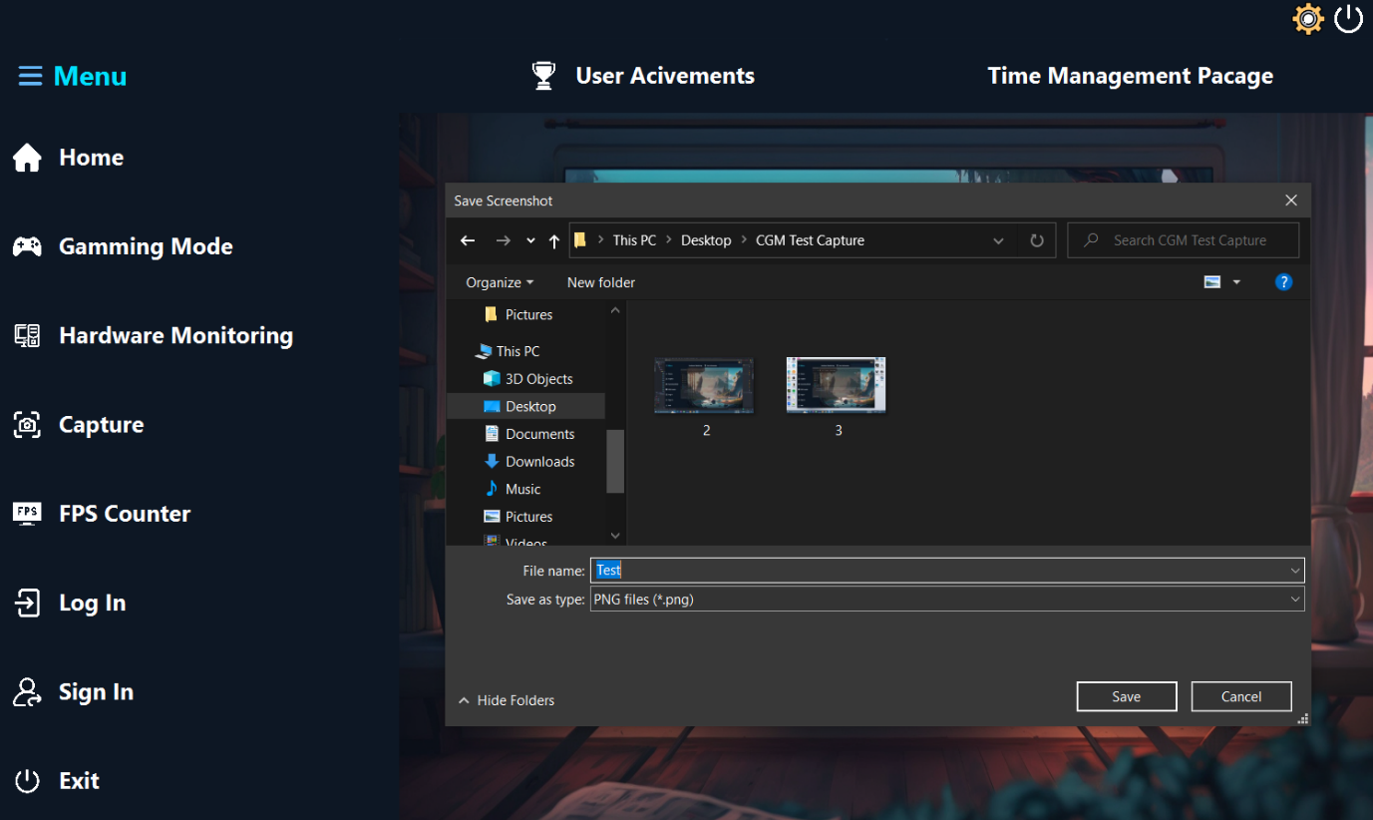

Figure - 5‑8: User interface(Screen capture)

Using the btnCapture button on the cgmMainPageController, users can capture their computer displays in the CGM programme. This function is handy for gamers who wish to share their gaming experiences or capture key moments while playing.

Snippet - 5‑10: Capture Button on action event

btnCapture.setOnAction(event -> {

captureAndSaveScreenshot();

});

The functionality for collecting and saving a screenshot of the user's computer screen in the CGM application is implemented as a class on the cgmMainPageController named captureAndSaveScreenshot(). This class includes the code that starts the screen capture process and saves the contents of the captured screen as an image or video file. The code for taking and saving the screenshot can be simply reused across the application by encapsulating it in a class. When the user clicks on the btnCapture button on the cgmMainPageController, the captureAndSaveScreenshot() method is called. This function is helpful for gamers who wish to record and share their gaming experiences.

Snippet - 5‑11: Capture and save screen shot method

private void captureAndSaveScreenshot(){

FileChooser fileChooser = new FileChooser();

fileChooser.setTitle("Save Screenshot");

fileChooser.getExtensionFilters().add(new FileChooser.ExtensionFilter("PNG files (*.png)", "*.png"));

fileChooser.setInitialDirectory(new File(System.getProperty("user.home")));

Stage stage = (Stage) MenuVbox.getScene().getWindow();

Rectangle2D screenBounds = Screen.getPrimary().getVisualBounds();

stage.setX((screenBounds.getWidth() - stage.getWidth()) / 2);

stage.setY((screenBounds.getHeight() - stage.getHeight()) / 2);

File file = fileChooser.showSaveDialog(stage);

if (file != null) {

try {

// Get the screen dimensions

Rectangle screenRect = new Rectangle(Toolkit.getDefaultToolkit().getScreenSize());

// Create a BufferedImage of the screen

BufferedImage capture = new Robot().createScreenCapture(screenRect);

// Save the BufferedImage to a PNG file

ImageIO.write(capture, "png", file);

} catch (IOException | AWTException ex) {

ex.printStackTrace();

}

}

}

Users can capture their computer screen via the CGM application by using the F1 key on their keyboard. The feature works by connecting the F1 key to the in-app snapshot function, allowing users to capture their displays fast and efficiently without having to click a button or navigate through menus. When the F1 key is pushed, an event occurs that initiates the screen capture process, which captures the contents of the user's computer screen and saves it as an image or video file that may subsequently be accessed and shared. This function is helpful for gamers who wish to record significant gameplay moments or share their experiences with others. By including this feature, the CGM app provides users with a quick and convenient way to capture their computer screens.

Snippet - 5‑12: F1 button

paneCGM.setOnKeyPressed(event -> {

if (event.getCode() == KeyCode.F1) {

captureAndSaveScreenshot();

}

});

### Management of FPS Counter

The CGM application calculates and displays frames per second (FPS), allowing users to monitor their PC's performance in real-time while running graphically demanding apps. This function assists users in optimizing system performance for a better user experience.

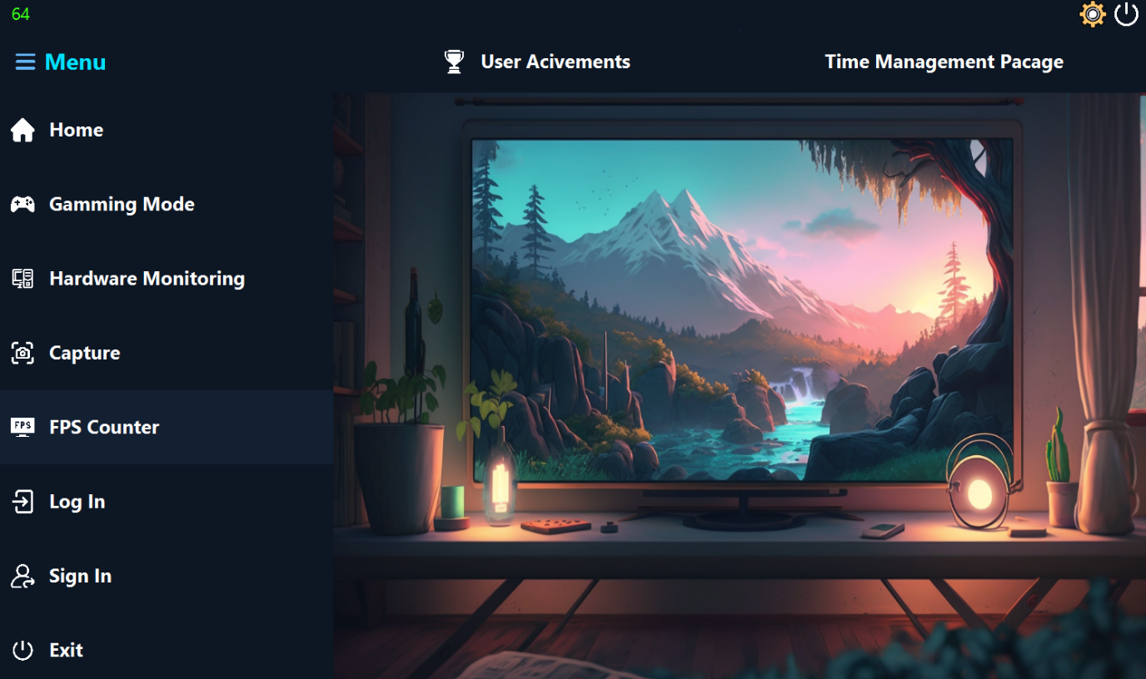

Figure - 5‑9: User interface(Fps Counter)

Users can check real-time computations of their computer's frames per second (FPS) in the CGM programme by clicking the btnFPS button on the cgmMainPageController. This functionality is implemented with a specialized technique that takes and calculates FPS data and shows it on the user's screen in real-time. FPS data allows users to assess the performance of their system when running graphically demanding applications such as games or video editing software. The FPS count is shown graphically in the cgmMainPageUI.fxml file, giving customers with an easy-to-use and simple option to optimize the performance of their system.

Snippet - 5‑13: FPS counter method

public void countFPS() {

AnimationTimer timer = new AnimationTimer() {

@Override

public void handle(long now) {

if (lastTime != 0) {

long diff = now - lastTime;

if (diff >= 1_000_000_000) { // 1 second in nanoseconds

lblFPS.setText(Integer.toString(fps));

fps = 0;

lastTime = now;

} else {

fps++;

}

} else {

lastTime = now;

}

}

};

timer.start();

}

The functionality of displaying the real-time frames per second (FPS) count in the CGM application is implemented via an action event on the btnFPS button on the cgmMainPageUI.fxml file. When the user presses this button, an event occurs that initiates the FPS counting process. This process gets and computes FPS data depending on the time it takes each frame to render and appear on the user's screen. The FPS count data is then displayed on the user's screen in real-time via a graphical interface. The logic for getting and displaying the FPS count data is implemented in the cgmMainPageController.java file, which provides the coding for this feature. The CGM programme gives customers with an intuitive and interactive approach to monitor the performance of their system by tying these files and classes together.

Snippet - 5‑14: btnFPS on action event

</Button>

<Button fx:id="btnFPS" alignment="BASELINE_LEFT" graphicTextGap="15.0" mnemonicParsing="false" onAction="#countFPS" prefHeight="100.0" prefWidth="350.0" stylesheets="@../../../CGM_CSS/CGM_Home.css" text="FPS Counter" textFill="WHITE">

### Management of User Achievement

The CGM application offers a function that allows users to view their computer gaming achievement data on their computer screen. This feature is intended to improve the user's gaming experience by allowing them to track and view their progress in various games. Data from the user's gaming account is retrieved and shown in a user-friendly and interactive interface, allowing the user to examine their achievements, progress, and statistics. Connecting to the user's gaming account via an API, getting achievement data, and presenting it on the user's screen via a graphical interface is required to provide this capability. The CGM app provides this capability, allowing users to stay motivated and interested while playing their favorite computer games.

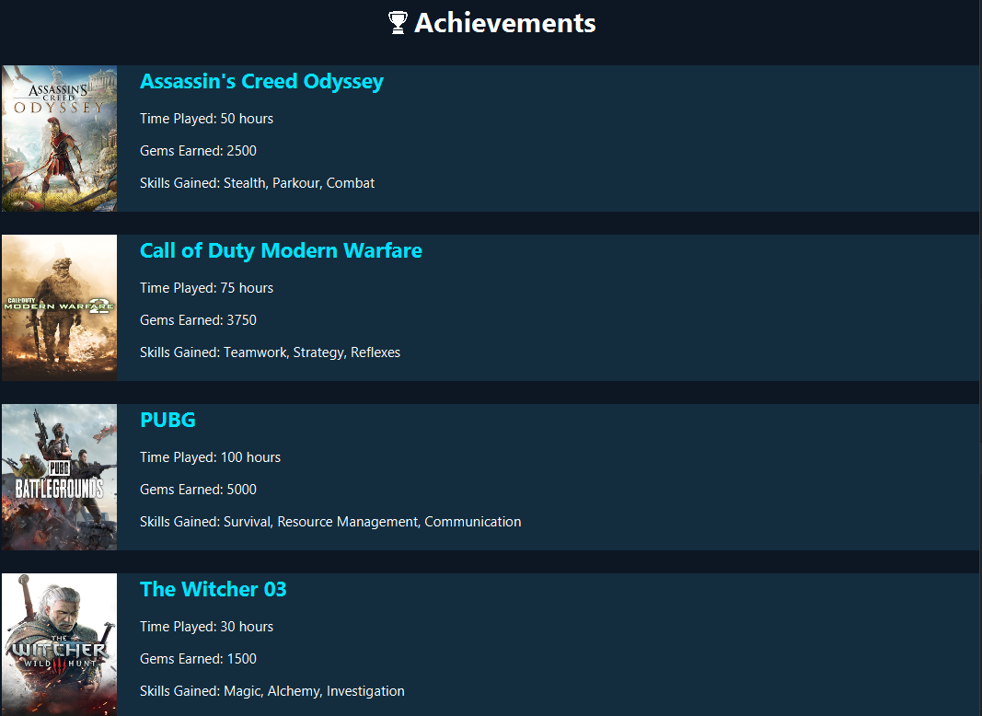

Figure - 5‑10: User interface(Achievements)

Through a specific component in the CGM application, users may view their achievement data from computer games. Click the Achievement button in the cgmMainPageController to access this functionality. When the user clicks on this button, an event is triggered, and the achievement details are displayed in an anchor window on cgmMainPageUI.fxml. Data from the user's game account is retrieved and shown in a user-friendly and interactive manner, allowing the user to view their progress and achievements in the game. The CGM app incorporates this functionality to provide an easy-to-use mechanism for users to track their achievements and improve their overall gaming experience.

Snippet - 5‑15: Achievement class call on home page

public void setOnAction1(ActionEvent event) throws MalformedURLException, RemoteException {

Stage stage = (Stage) btnAchivevements.getScene().getWindow();

stage.show();

AchievementMonitor();

}

The UI for the Achievement class is produced in the CGM programme in the achievementManage.fxml file, which contains the layout and design elements for the user interface. When the accomplishment button on the CgmMainPageController is hit, an event is fired that loads the achievementManage.fxml file and shows the achievement data user interface. The achievement data is supplied to the achievementManage.fxml file's label element, which is in charge of displaying the data to the user. Win Data may contain information such as the name of the win, the game in which it occurred, the date it occurred, and any connected awards or bonuses. The CGM app incorporates this functionality to provide users with a simple method to view and manage their sports achievements from a single spot.

Snippet - 5‑16: Achievement FXML on action button

<Button fx:id="btnAchivevements" graphicTextGap="15.0" mnemonicParsing="false" onAction="#setOnAction1" prefHeight="66.0" prefWidth="425.0" stylesheets="@../../../CGM_CSS/CGM_Home.css" text="User Acivements" textFill="WHITE">

### Management of Time Management Package

The default function of cgmMainPageController provides a time management package that allows users to properly manage their time. This feature is intended to assist users keep organized and on track, particularly when they have several tasks and projects to perform. The time management software contains a to-do list, a calendar, and a reminder system that alerts users when crucial deadlines approach. These capabilities are achieved using specialized methods that record and show data in a user-friendly interface, allowing users to manage their time more effectively and remain productive. The CGM app helps users improve their time management skills and achieve their goals more efficiently by giving this capability.

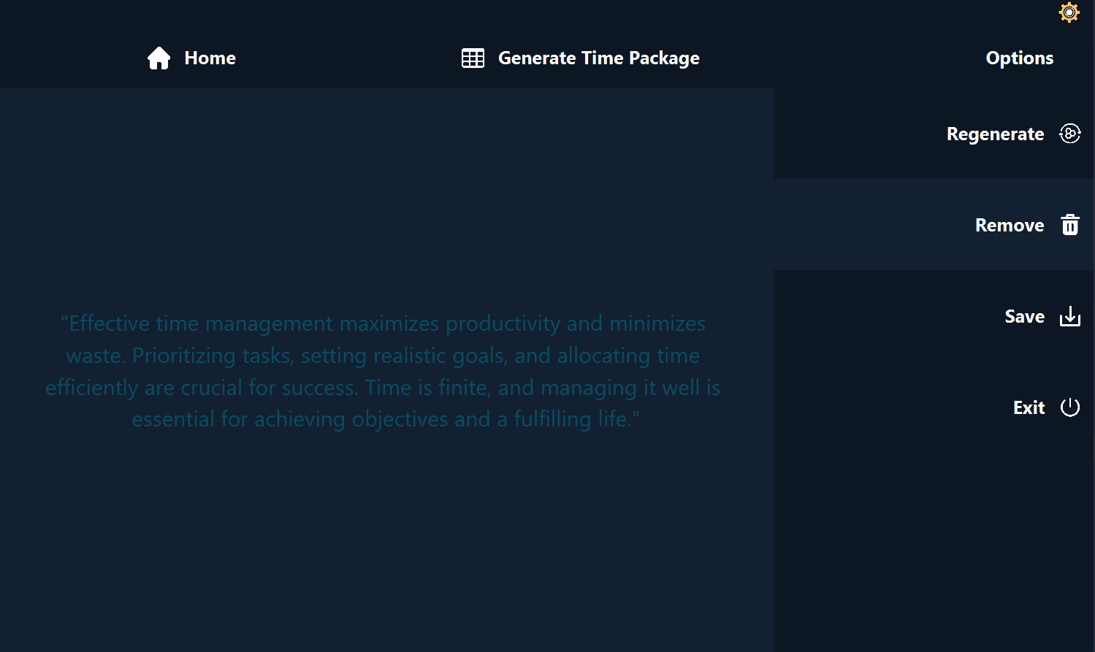

Figure - 5‑11: User interface(Time management)

The user can produce a customised time management package in the CGM application's time management function by clicking the "Generate Time Package" button in the time.fxml file. This function integrates numerous time management tools and strategies to provide the user with a comprehensive package for managing their time successfully. On the user interface, the created time package is displayed in a legible style. If the user is unhappy with the created package, he or she can re-generate it by clicking the "Regenerate" button. Writing code that generates the time management package and refreshes the user interface with new data is required for integration of this functionality. By including this feature, the CGM app enables users to better manage their time and be more productive.

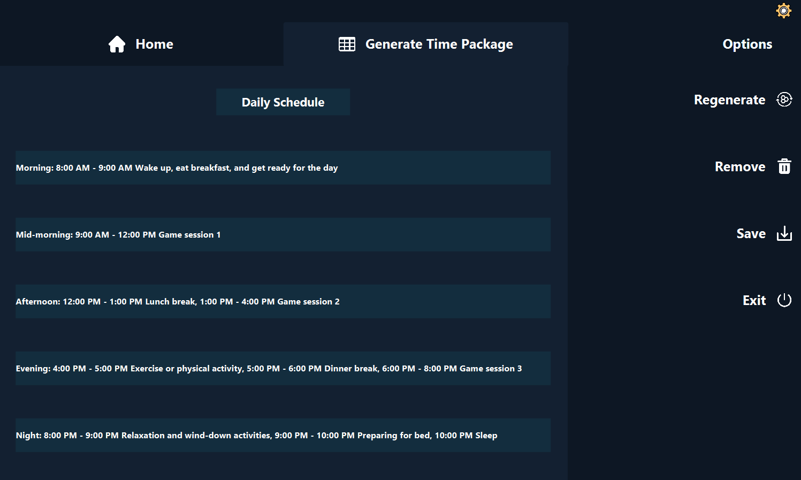

Figure - 5‑12: User interface(Generate)

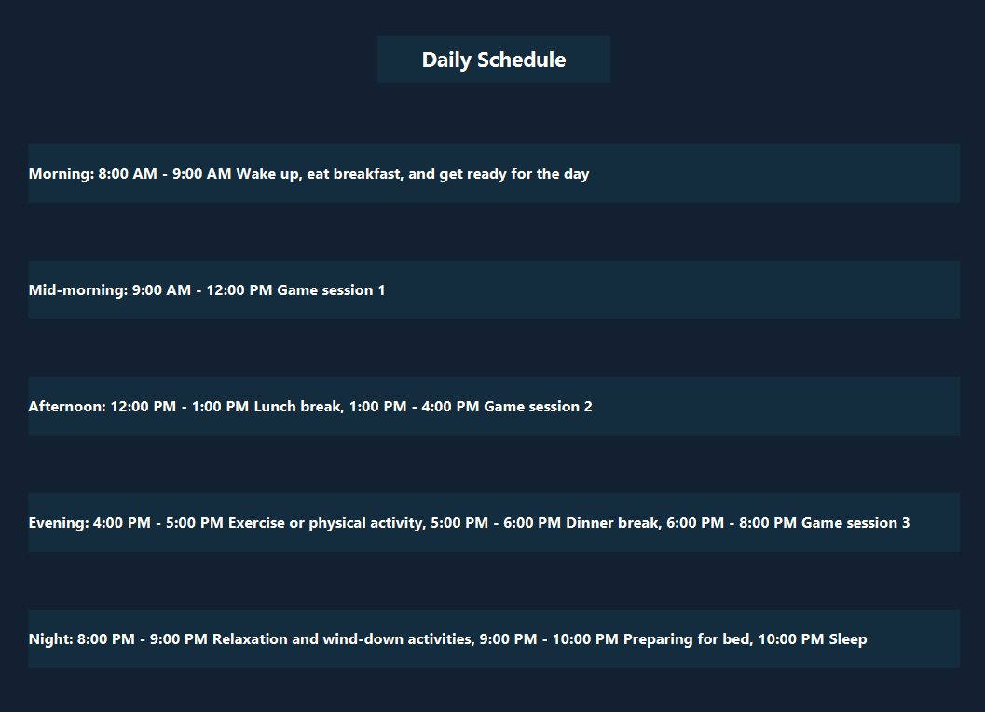

Figure - 5‑13: User interface(Generated time package)

To build the time management package in the CGM programme, a database connection must first be established. This connection is necessary to access and retrieve data from the database that was used to construct the user's time management package. Creating a database connection entail supplying the necessary credentials and connection parameters such as database name, username, and password. After connecting, the data may be viewed and used to produce the time management package. This phase is crucial to ensuring that the time management package is correct and up to date, giving users with a dependable tool to manage their time successfully.

Snippet - 5‑17: Database connection

@Override

public void initializes(URL url, ResourceBundle resourse){

DatabaseConection conection = new DatabaseConection();

Connection connection = conection.getConnection();

}

The CGM app allows users to store or remove their time management plans. This feature is accessible via the time management feature, which provides a personalised strategy for managing the user's time. After creating the design, the user can save it on their computer by clicking the "Save" button. This saves the design as a file, which may subsequently be viewed and used. If the user determines that the plan is no longer required, he or she can quickly remove it by pressing the "Remove" button. This removes the plan from the programme and releases any resources it is currently utilizing. The CGM app allows users to manage their time more effectively and efficiently by providing these options.

Snippet - 5‑18: Remove method

public void removeOn(ActionEvent event) {

Stage stage = (Stage) btnMainMenu.getScene().getWindow();

stage.show();

remove();

}